Contents

74. Introduction to **Validation** in AEM touch UI Dialog 3

75. Adding JavaScript via **CQ.Authoring.Dialog** 4

76. Adding JavaScript via **IncludeClientlibs** 9

77. **Input field Validation** using **Granite UI** 13

78. Show/Hide dialog fields with a Dropdown in AEM 18

79. Show/Hide dialog fields with a Checkbox in AEM 24

80. Sling Servlet using **Path** method 29

81. Sling Servlet using **ResourceType** method 33

# 74. Introduction to **Validation** in AEM touch UI Dialog

For example, below is a dialog box where we need to add validation to **restrict user to enter valid email Id**.

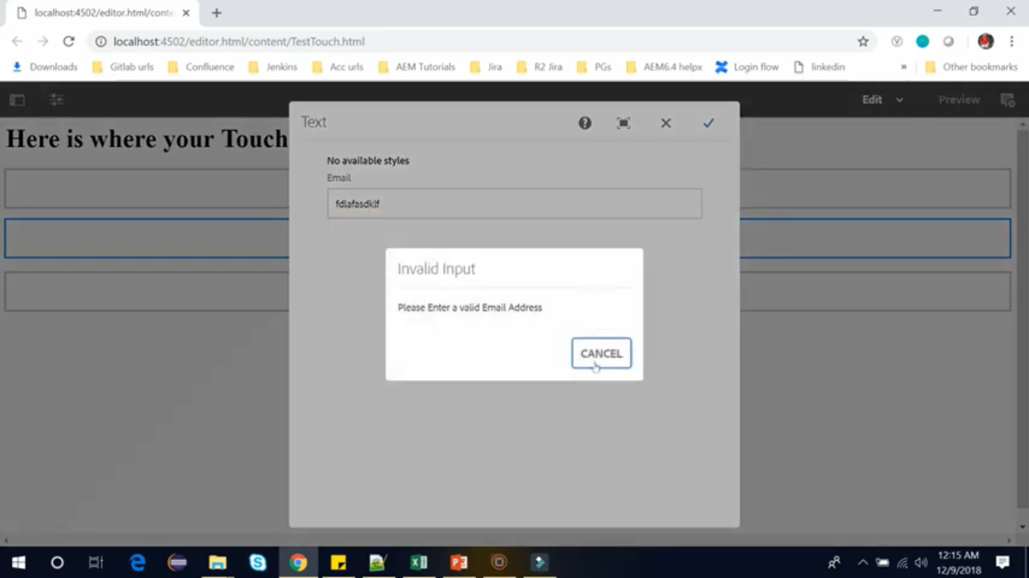

Our dialogs are collection of form fields and checking data before it is submitted can save a lot of headache in your project.

Input validations allows you to check data, before the dialog is submitted.

Granite UI provides easy way to add custom validations for your dialog box.

Custom validation requires adding custom java scripts and we can accomplish this using client library.

Now we have **2 methods** to add these custom validations

1. CQ.Authoring.Dialog
2. Adding JS via IncludeClientLibs

# 75. Adding JavaScript via **CQ.Authoring.Dialog**

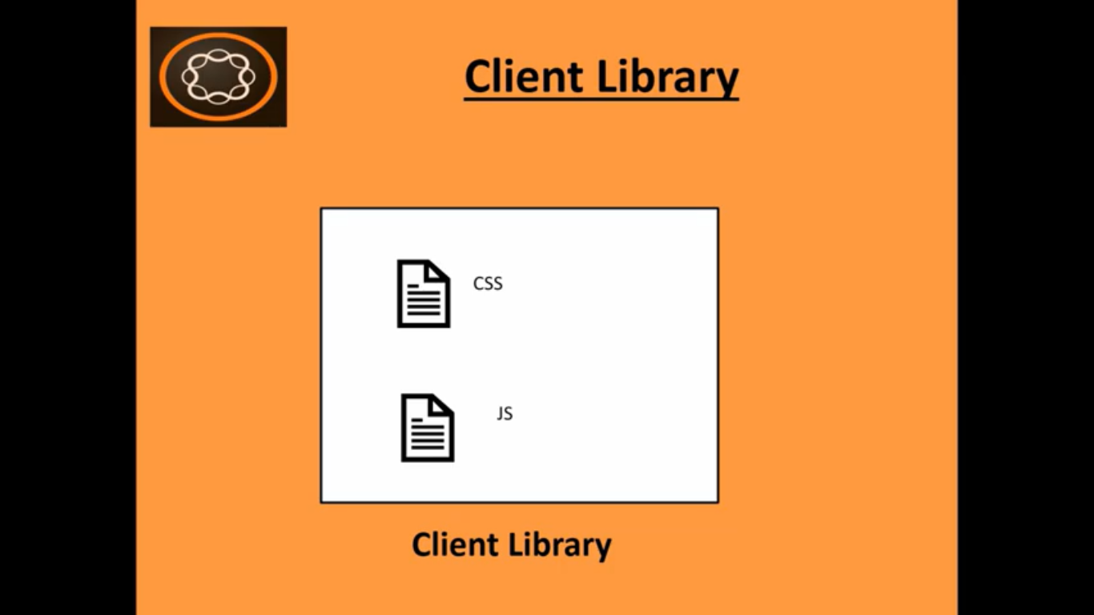

As we know AEM uses Client Library to manage CSS and Javascript.

Client Libraries are registered Globally in AEM using a category name.

You assign a category to Client Library for identification and then we call on the category to add CSS and JS to the browser.

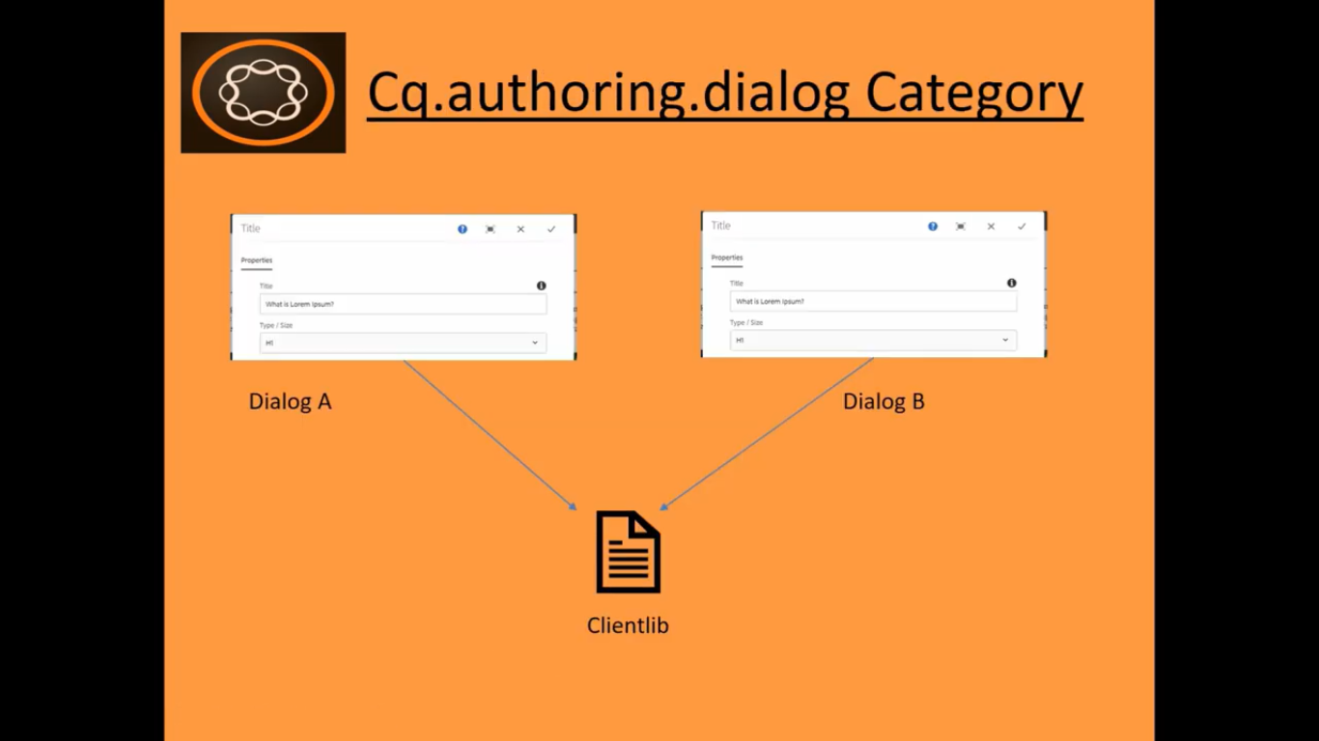

AEM has Client Library category specifically for dialogs. That is named **CQ.AUTHORING.DIALOG**.

So we can create Client Library with **CQ.AUTHORING.DIALOG** to use any custom JavaScript within our dialogs.

Here important point to note is that adding JavaScript this way will add it to every dialog with an AEM even the dialogs that are out of the box (built-in available with AEM by default).

Now lets create a Client Library first with the category name **CQ.AUTHORING.DIALOG** so thatit can apply to every dialog box in AEM.

Go to Sites Console. <http://localhost:4502/sites.html/content/demotraining>

Open **English** page under Site named **DemoSite**. <http://localhost:4502/editor.html/content/demotraining/en.html>

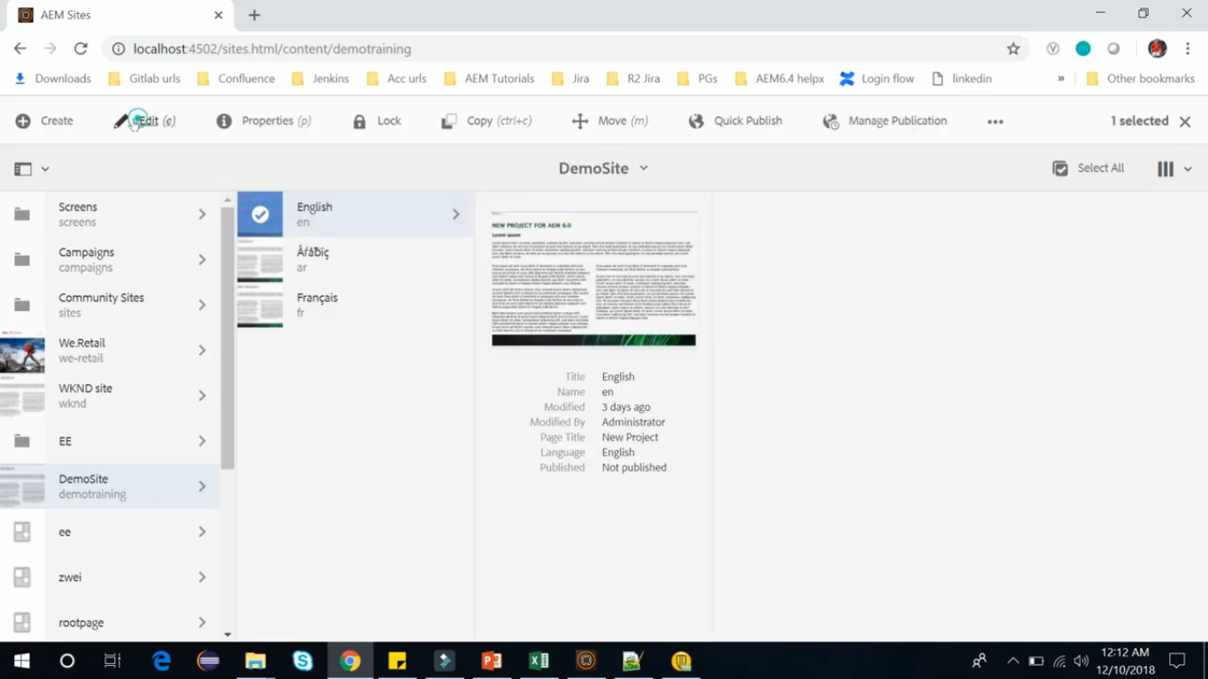

We have several dialog on English page such as on Title component, Text component, etc.

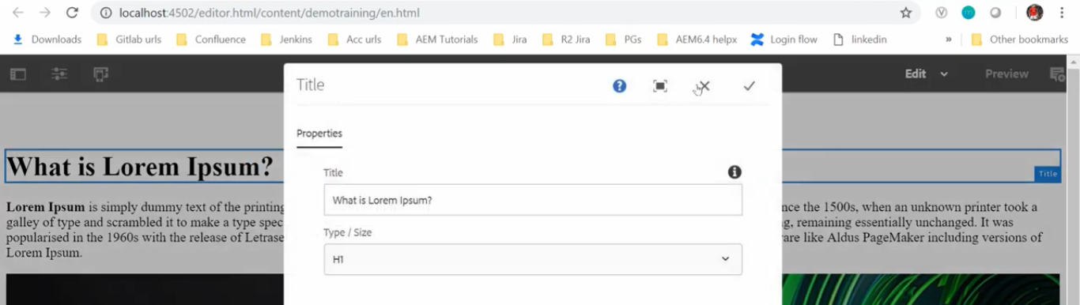

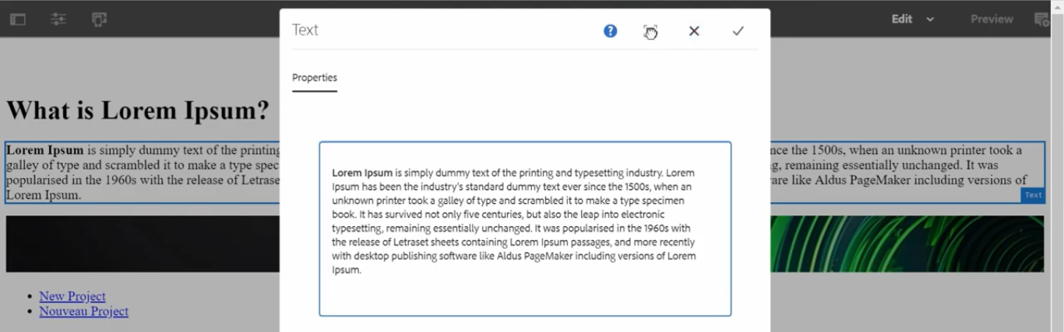

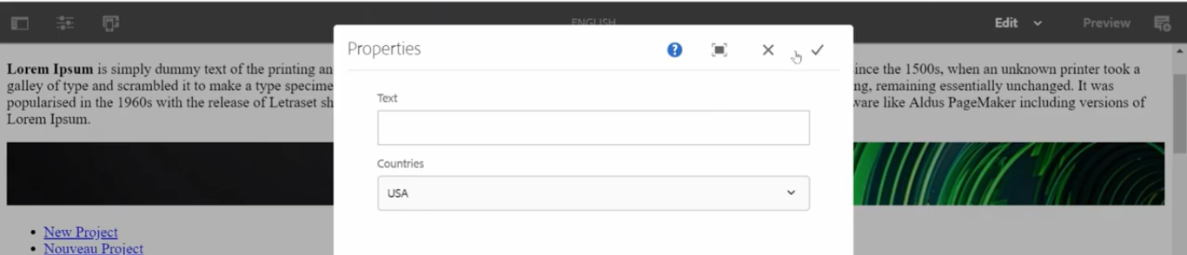

Go to CRX/DE, Go to path **/apps/demotraining/components/content/helloworld/clientlib-authoring**

We have below 2 properties set for this node/folder.

|  |  |
| --- | --- |
| **Field Name** | **Field Value** |
| jcr:primaryType | cq:ClientLibraryFolder |
| categories | cq.authoring.dialog |

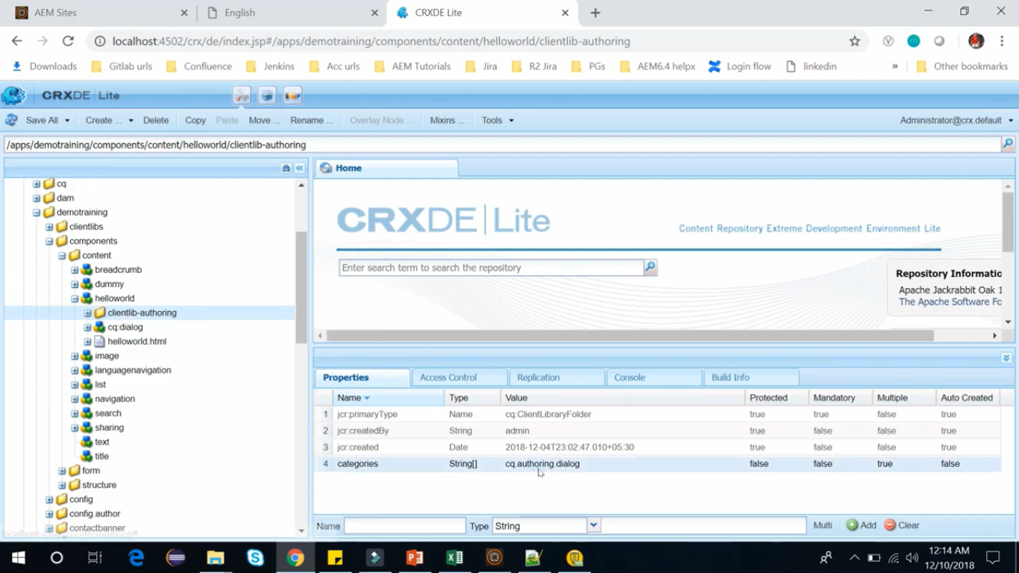

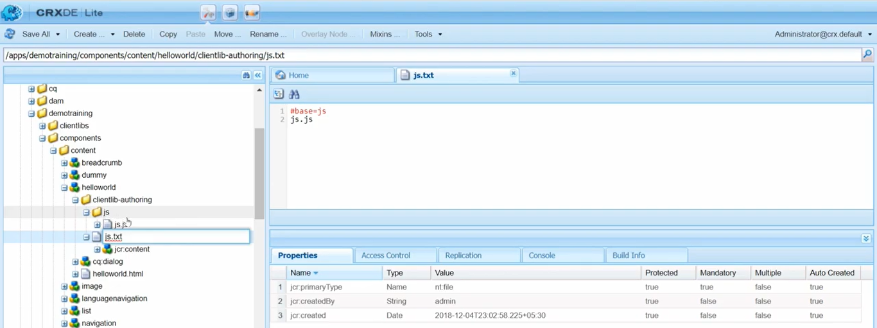

We have create js.js file inside JS folder inside our client library. js.text file also inside our client library.

See their file contents in above and below images.

Since folder name is **js** it is written as **#base=js** and file name is **js.js** so it so written as **js.js**

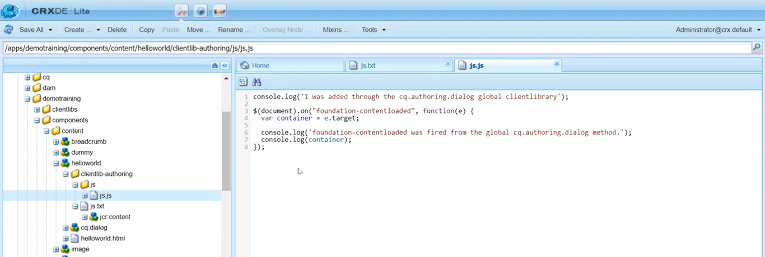

When **Granite UI** injects new content into the DOM, **Foundataion-contentloaded** event is called.

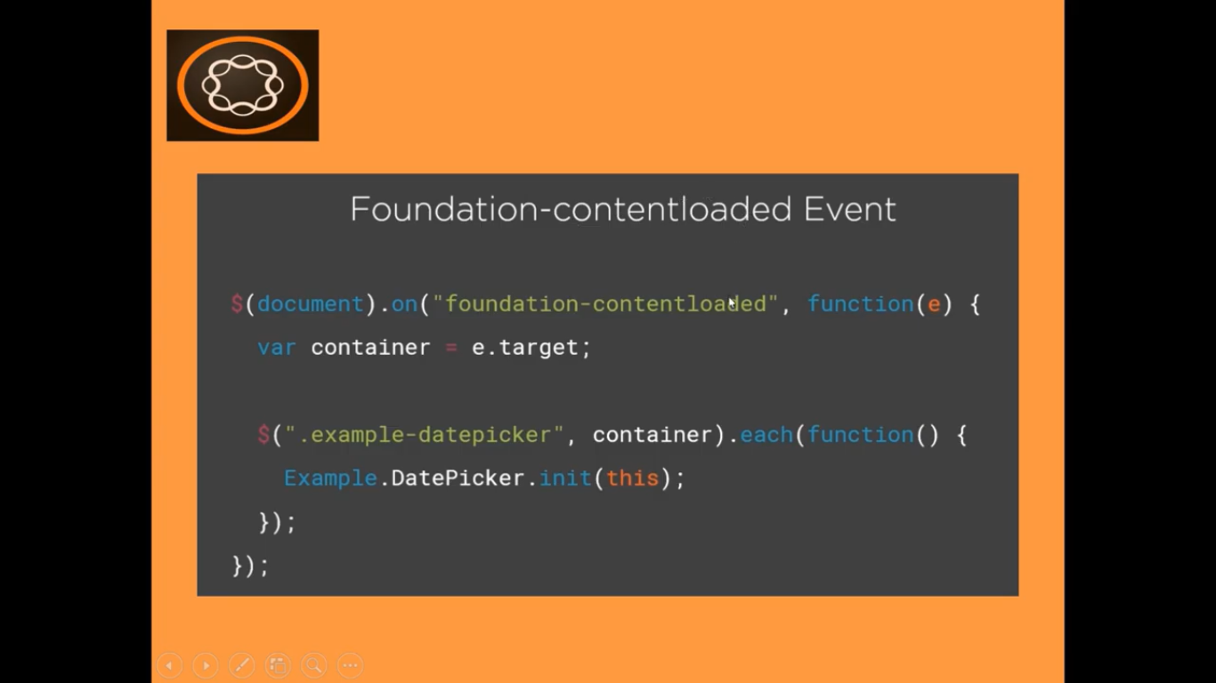

When **Granite UI** loads a dialog, the **Foundataion-contentloaded** event is called.

When listening for this event, the container is available in event target (line number 2 of the code).

It is recommended that the listener uses the container to scope its operation because this event could be firing many times and you want to keep JavaScript scoped to its purpose.

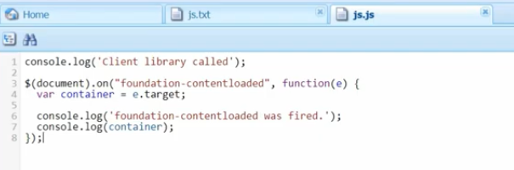

You can see our content has been fired 3 times on the page load.

You can expand the document to see that the actual document was event target.

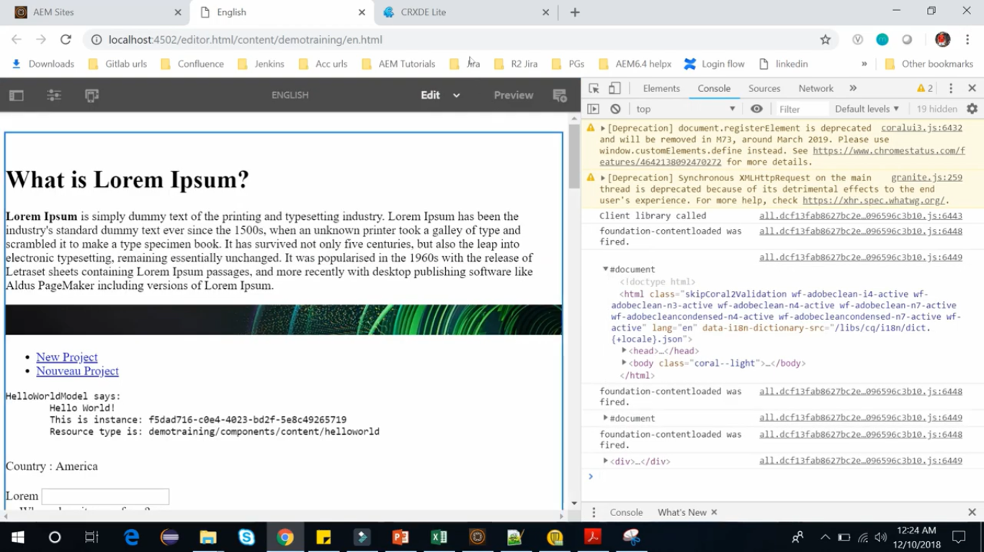

Double Click on HelloWorld to open its dialog. You can see in Developer Tools Console, that target of this is simply dialog shown in image (coral-dialog). As we have used **CQ.AUTHORING.DIALOG** as category for the client library, we can see this event getting fired from any dialog.

In short, as discussed at the start of this section, AEM has Client Library category specifically for dialogs. That is named **CQ.AUTHORING.DIALOG** and it has been added to every dialog within an AEM.

If we only want JS to fire on single dialog specifically, then in that case we can use Granite UI component include client-libs.

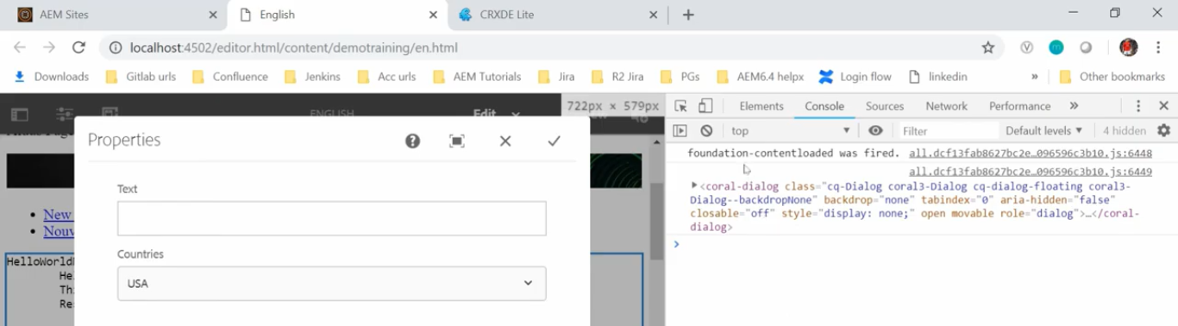

# 76. Adding JavaScript via **IncludeClientlibs**

In this section, we will learn how to **add JavaScript** through **IncludeClientLibs** granite UI component.

This method is used when you want to include Client Library or JS, specific to a single dialog, unlike **CQ.AUTHORING.DIALOG** which was firing JS in every single dialog.

In last section, on **English** page, we have added JavaScript, using **CQ.AUTHORING.DIALOG** method, where we had used ClientLib hello world client library.

We can check Hello World component from the CRX/DE path

**/apps/demotraining/component/content/helloworld/clientlib-authoring.**

We will change this Client Library **clientlib-authoring.**

Change its property from properties pane as below

|  |  |  |  |
| --- | --- | --- | --- |
| **Field Name** | **Field Type** | **Old Value** | **New Value** |
| categories | string[] | cq.authoring.dialog | cq.include |

Click on **Save All** button.

Now we have **Client Library** and its **categories name** is **cq.include.**

Inside this same **Client Library,** we have JS and we want to keep this JS as same as earlier.

My client library is ready now.

Now let’s open the node **cq:dialog** and within this **items** node we have 3 nodes

1. text
2. countryList
3. listFrom.

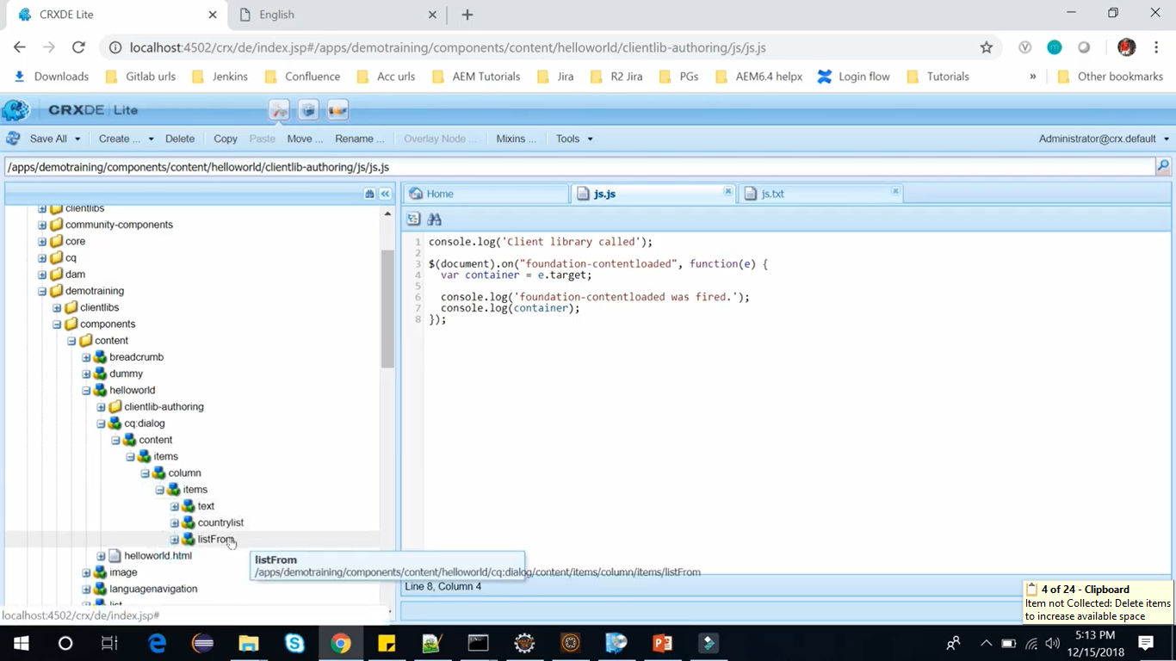

Open Hello World component’s dialog box. Here we can see Text, countryList dropdown and a checkbox .

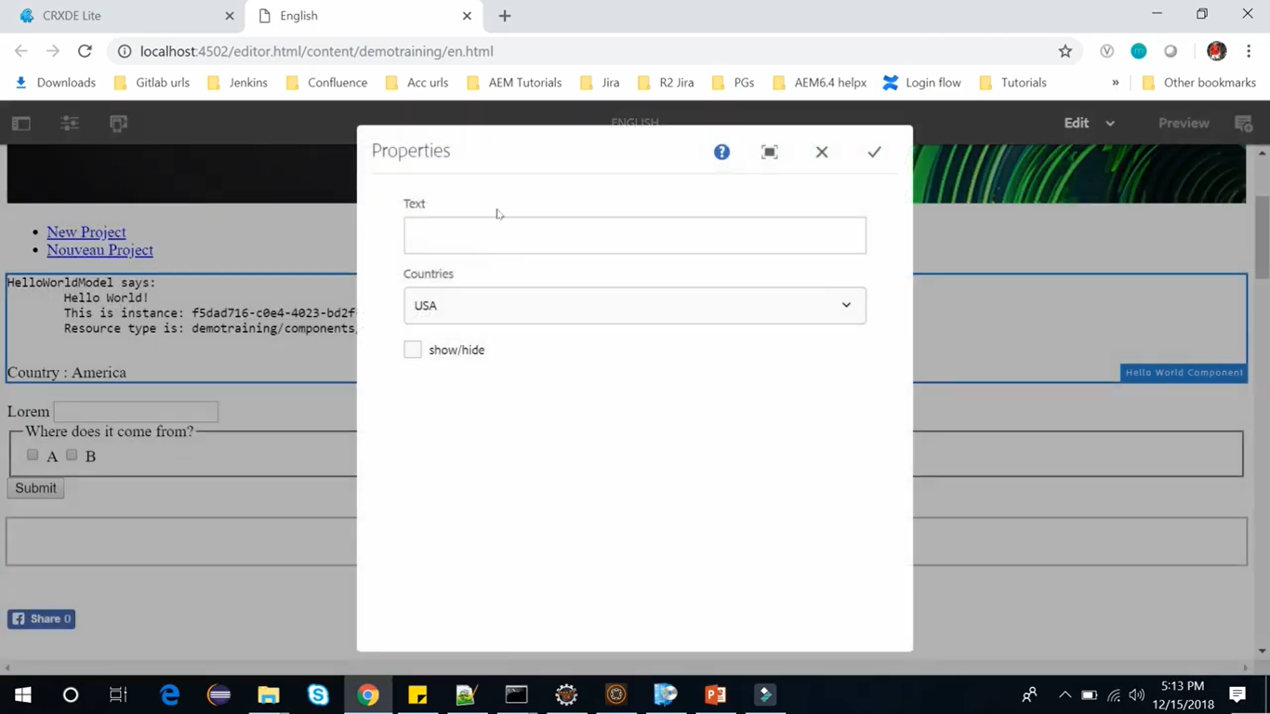

Now just like any other component add a node and give it all properties to all on our client library.

Let’s do this under the **items** node at CRX/DE path **/apps/demotraining/component/content/helloworld/clientlib-authoring/cq:dialog/content/items**

items simply render the components.

If we will try to use it outside of an item node it wouldn’t get rendered.

Right click on this **Items** node --> Create --> Create Node --> Set **Name** to “**include-clientlib”** --> **Ok** button

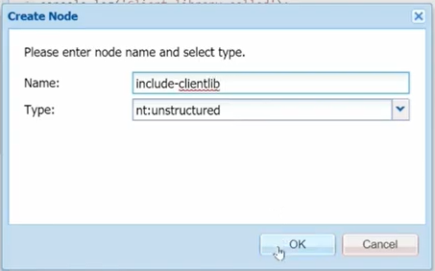

Add below 2 properties from properties pane to **include-clientlib** node.

|  |  |  |
| --- | --- | --- |
| **Field Name** | **Field Type** | **Field Value** |
| sling:resourceType | String | granite/ui/components/coral/foundation/**includeclientlibs** |
| js | String | cq:include |

Click on **Save All** button.

Now we are done with the coding.

Refresh **English** page and open the **console window (developer tools)**.

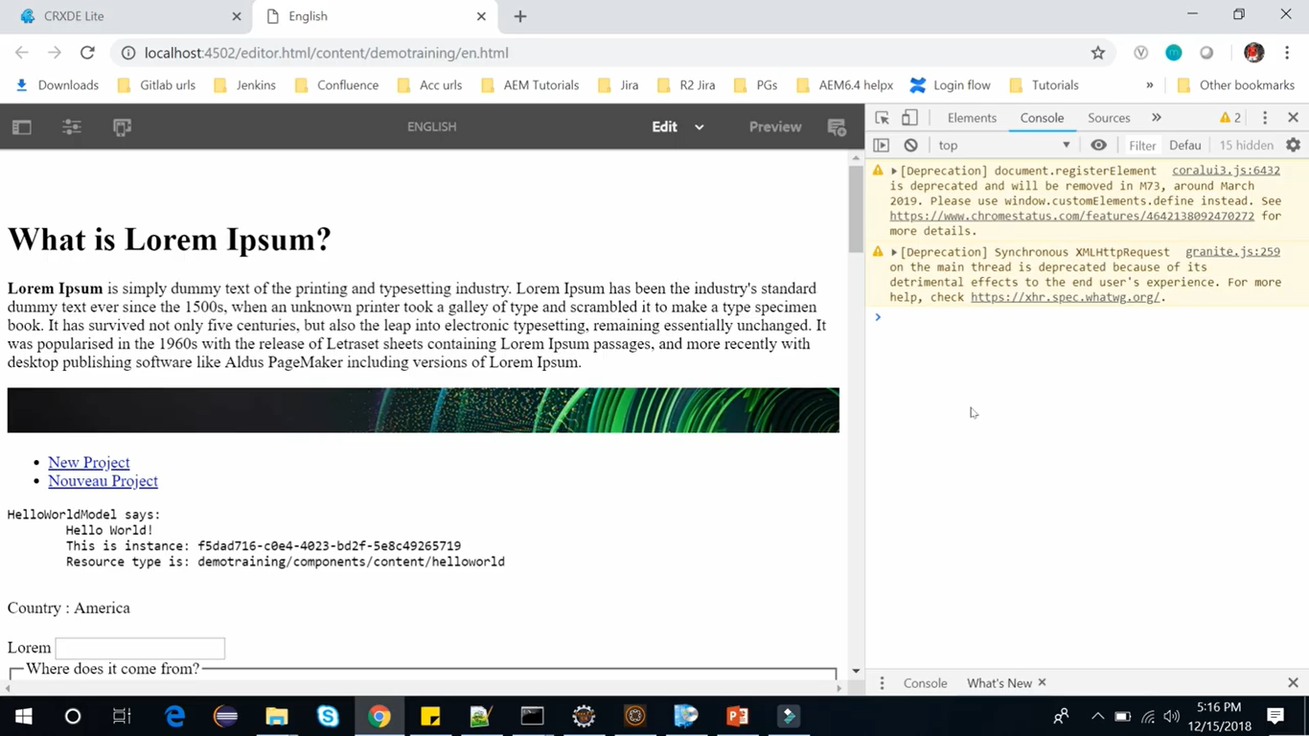

As you can see here in **console window (developer tools)** while loading the page, there is **no** console log.

That means, it has not called any client library, like, it was calling in our **CQ.AUTHORING.DIALOG** method.

Now let’s clean console and let’s open dialog of first paragraph (Lorem ipsum - text component).

We can see that no client library is getting called and there is **no** console log. So close it.

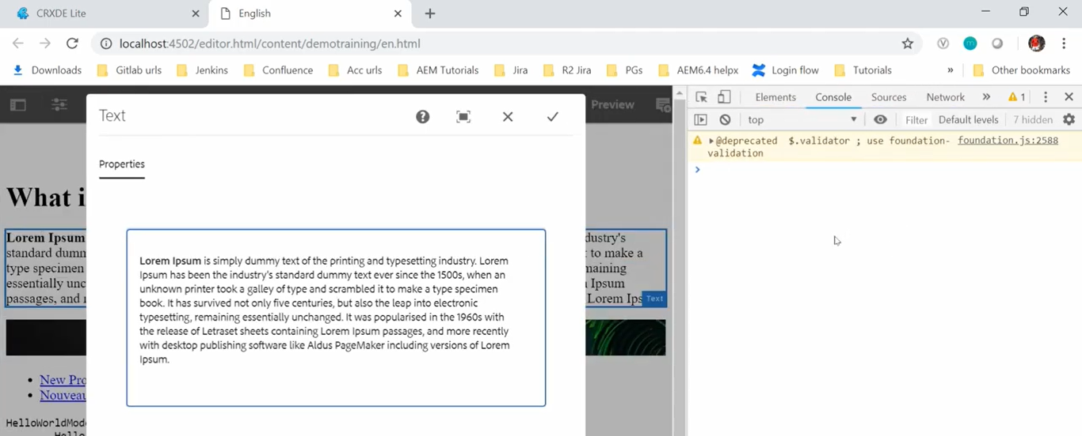

But in this lecture, we have added client library in our hello world.

So, let’s open the **hello world components** **dialog box**.

Here we can see that the client library has been called and **console log** is displayed in Console Window.

The target was our coral dialog

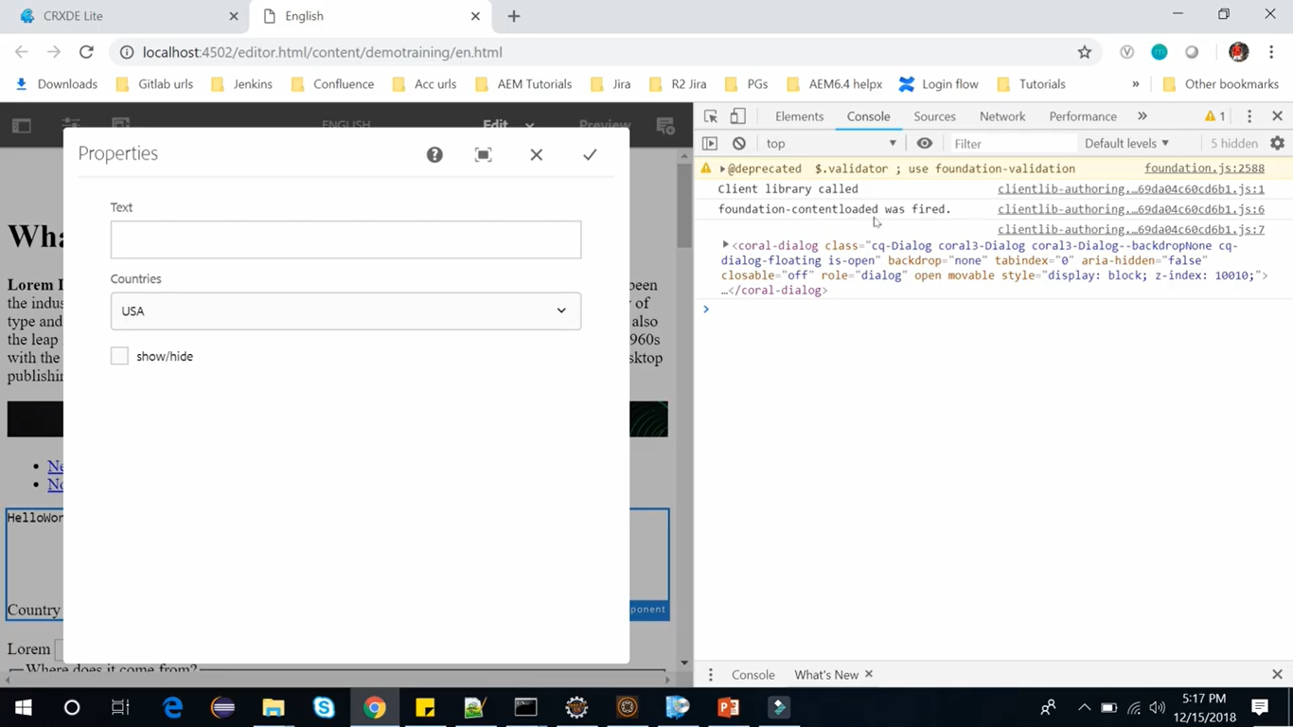

So. if you only want JS to fire on single dialog then we can use this granite UI component **includeClientLibs**.

# 77. **Input field Validation** using **Granite UI**

As now you know how to add custom JavaScript in your dialog.

So, now we can start writing custom validation for your input fields in AEM using granite UI.

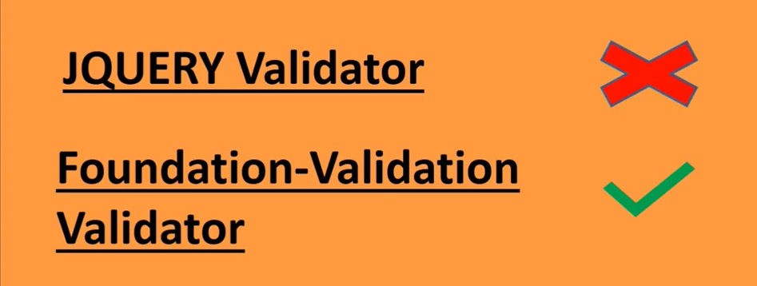

Previously **jQuery validator** was used for **Form Validation**. But it is no longer the case as it is considered deprecated now and maintained only for backward compatibility. The **new way** for validation *AEM 6.2 and onwards* is **Foundation-Validation approach**.

**Foundation-Validation** captures the **dialog’s submit event** to cancel and stop when the form is invalid.

So, if any of input fields is invalid, it stops the form from submitting until validation errors are fixed and validation happens through the validator.

Now let’s create our input validation using foundation validation.

Let me open my **AEM -> site console -> demo site ->** Open **English page** --> double click to **Hello world component** --> this will open **a dialog**.

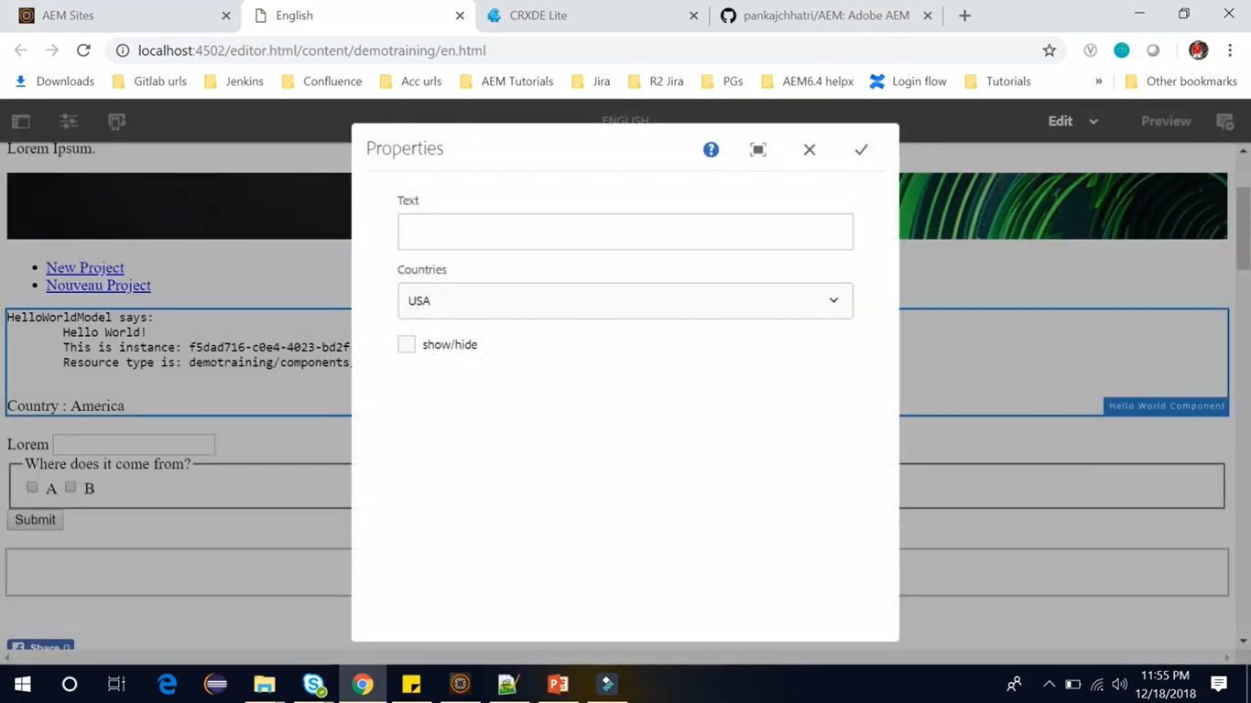

Here we have this **text field**. In this section we will do the **validation** for this **input text field**.

So, let’s see how we can do **validation** using **Foundation-Validation**.

So, to do the validation we write a client library which we had created in the last section.

Go to the **CRX/DE** path **apps/demotraining/components/content/helloworld**.

In **helloworld** component, we have created this client library named **clientlib-authoring** where we have **JS** folder, **js.js** and **js.txt**. The **categories** field of **ClientLib** set to **cq.include** which is used in **cq.dialog** node.

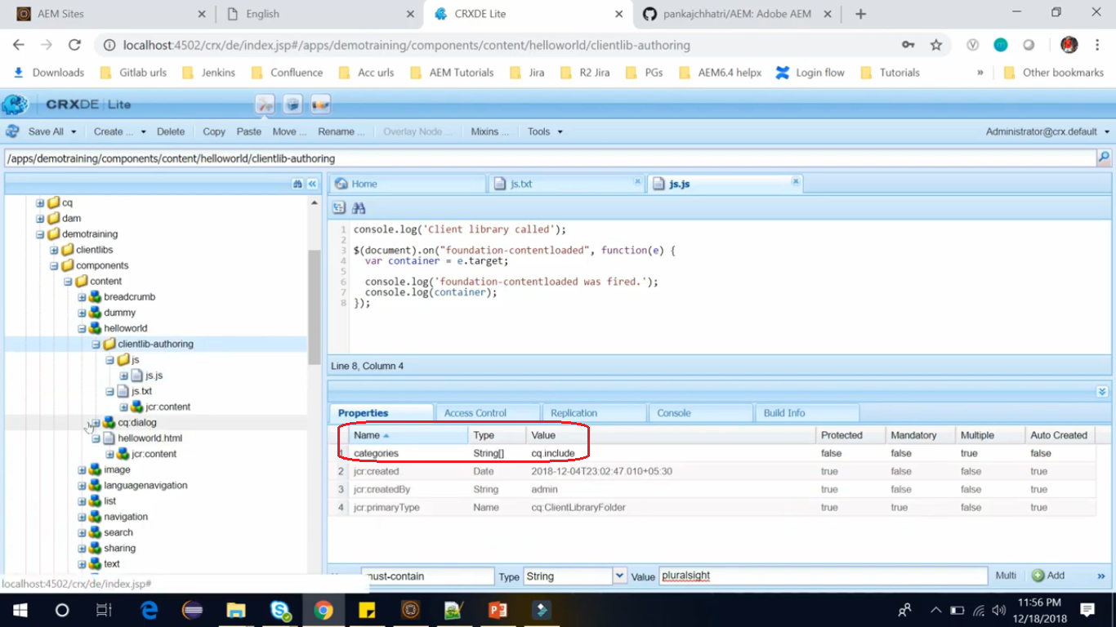

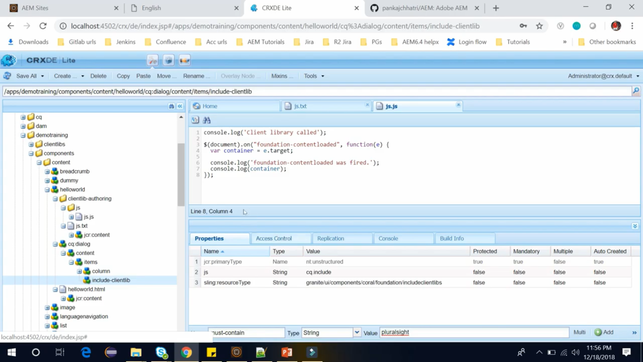

Go to the **CRX/DE** path **apps/demotraining/components/content/helloworld/cq.dialog/content/items/include-clientlib**

We had created **include-clientlibs** node, in my last section.

In this section, we will replace this **custom JavaScript** by the **Foundation-Validation JavaScript**.

So, to open that **Foundation-Validation JavaScript,** **copy** the code from below URL and **paste** in **js.js**

Go to <https://github.com/pankajchhatri/AEM> --> Go to [Developer course](https://github.com/pankajchhatri/AEM/tree/master/Developer%20course) --> [Developer course](https://github.com/pankajchhatri/AEM/tree/master/Developer%20course) --> [Chapter 10 Authoring Structure Components](https://github.com/pankajchhatri/AEM/tree/master/Developer%20course/Chapter%2010%20Authoring%20Structure%20Components) --> [Lab Activity - VI](https://github.com/pankajchhatri/AEM/tree/master/Developer%20course/Chapter%2010%20Authoring%20Structure%20Components/Lab%20Activity%20-%20VI) --> [multifieldpage](https://github.com/pankajchhatri/AEM/blob/master/Developer%20course/Chapter%2010%20Authoring%20Structure%20Components/Lab%20Activity%20-%20VI/multifieldpage)

Here to create a **new validator** for **Form Validation,** you need to register a new validator to the **registry** using **foundation.validation.validator.** When you register a new validator, **you pass in an object**.

$(window).adaptTo("foundation-registry").register("foundation.validation.validator", {

selector: "[data-should-contain]",

validate: function(el) {

var shouldContain = el.getAttribute("data-should-contain"); //aem

console.log('validating text contains aem');

console.log('input should contain ' + shouldContain);

var input = el.value; //input added by author

if (input.indexOf(shouldContain) === -1 ) {

return "The field should contain " + shouldContain + ". It's current value is " + el.value + ".";

}

}

});

In above code, we am passing an object (all the lines, except the first line of code ) and this passed object (from second line and onwards) should contain a **selector** objectand **validate function**.

If **validate** **function** returns anything **other than** **true** it will be considered **invalid**.

Above JavaScript code starts with **adapting the window to the function registry** and then it is **registering** the **Foundation-Validation** validator which is how we add a new validator to a granite UI while registering a validator.

Here our **selector** is **data-should-contain**. We can simply add the selector to one of the inputs to our dialog.

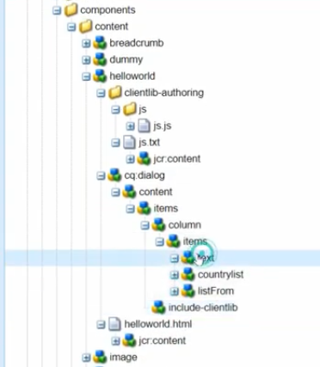

So, we will add the selector in the input of the dialog field and the input is the first node which is in which is this **text** (**see image above**) in the valid function.

**Code Logic:** We are taking data attribute and then we are taking value of input and testing the value of data element is there in text input or not. If it **doesn’t exist** there it will **throw the error**.

Now in the dialog let’s add that attribute.

Right click on **text** node --> Create --> Create node --> name it **granite:data** --> Click OK --> Click “Save All”.

We can add the data attribute by creating a **granite:data** of sub resource and at our selector it is **data-should-contain.** So, **copy** selectorspartialtext **‘should contain’.** Addbelow new property to **granite:data.**

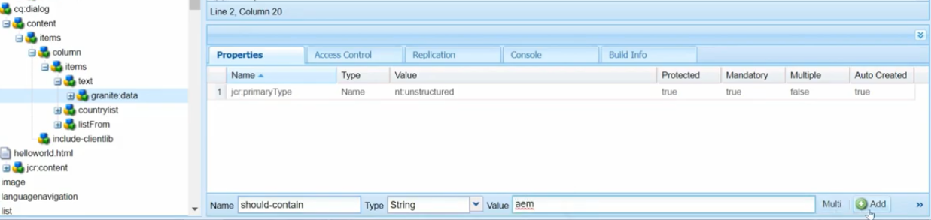

Click on **Save All** button.

So, if any input coming from the text field should have word **‘AEM’** in it otherwise it will throw an error

Let’s see how it works. Go to our **English** page --> **Refresh** page --> Double click to **hello world** component. It will run our **JavaScript** after **putting any text** and do **tab out**.

Let’s put the text “Hello World” here you can see it is showing an error **“this field should contain AEM and its current value is hello world”.**

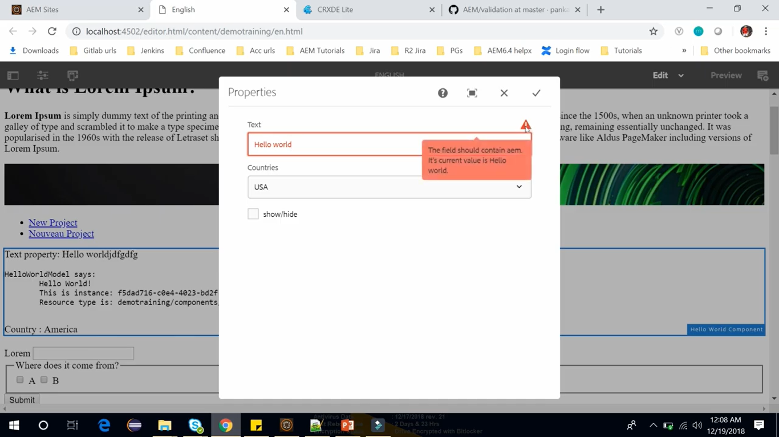

It doesn’t contain AEM that’s why it is not allowing us **let’s write hello AEM and it should allow** us. Here you can see the error has been removed now you can submit this.

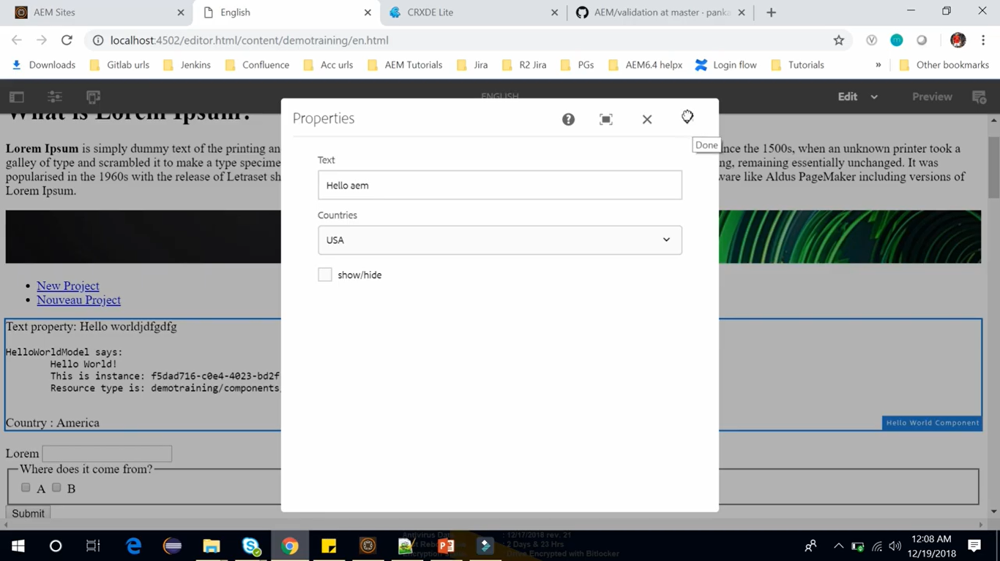

# 78. Show/Hide dialog fields with a Dropdown in AEM

In this section, we am going to show you how you can show or hide direct fields with a dropdown in AEM.

Let’s open **AEM** -> **Site Console** -> **DemoSite** -> **English** page.

On **English** page, we have used this **List** component which is the out of the box component of AEM.

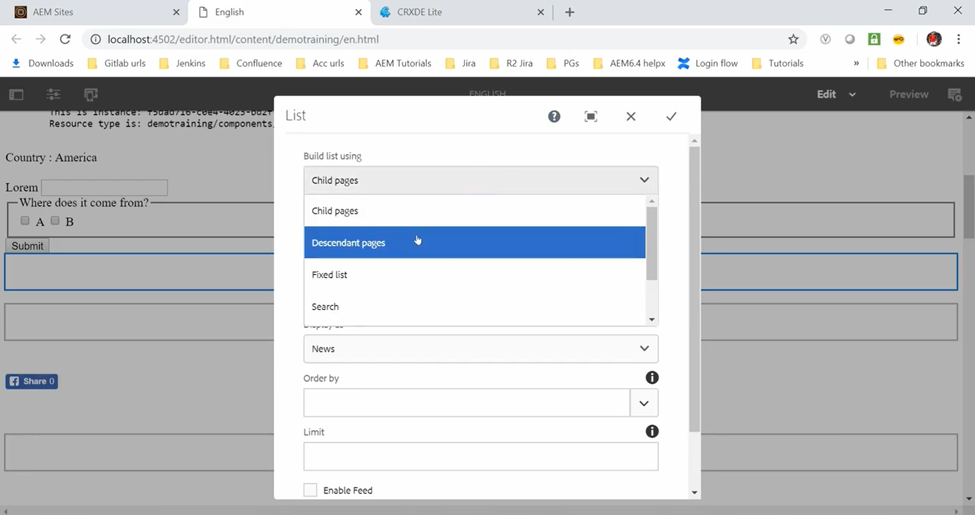

If we Double click to **open** it, we will see a **dialog**, where we have selected dropdown to **Child Pages**.

If we change it to **Descendent pages** or **Fixed list** or **Search.** Based on selection, below field will change.

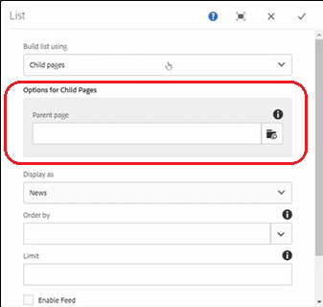 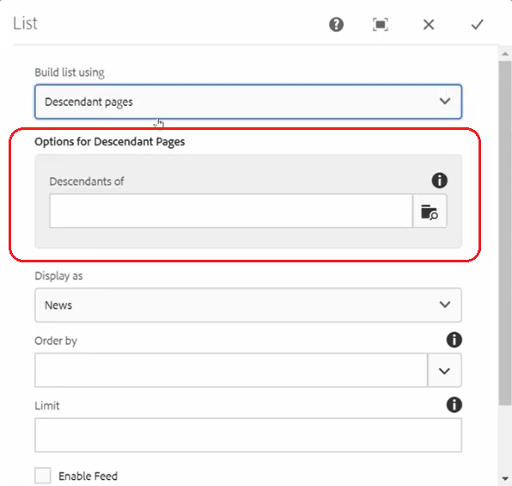

Let me set this to search. this option is getting change to the search.

So, there may be a requirement when you want to change the dialog fields based on the selection of checkbox or dropdown.

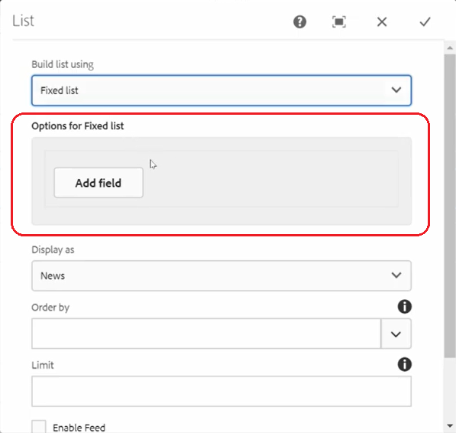 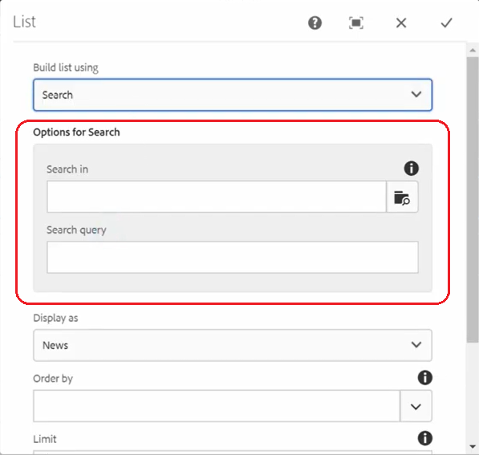

There is a secret show and hide client library in AEM. You can use JavaScript from this client library to show or hide the fields based on the dialog select dropdown.

This client library is located at JCR path. /**libs/cq/gui/components/authoring/dialog/dropdownshowhide**.

Let’s open this path. Go to CRX/DE path /l**ibs/cq/gui/components/authoring/dialog/dropdownshowhide**.

So, this is the **client library**, let’s open this we have this JS **dropdownshowhide.js** and this client library has a category **cq.authoring.dialog**. That means this JavaScript is **available in every dialog** of AEM.

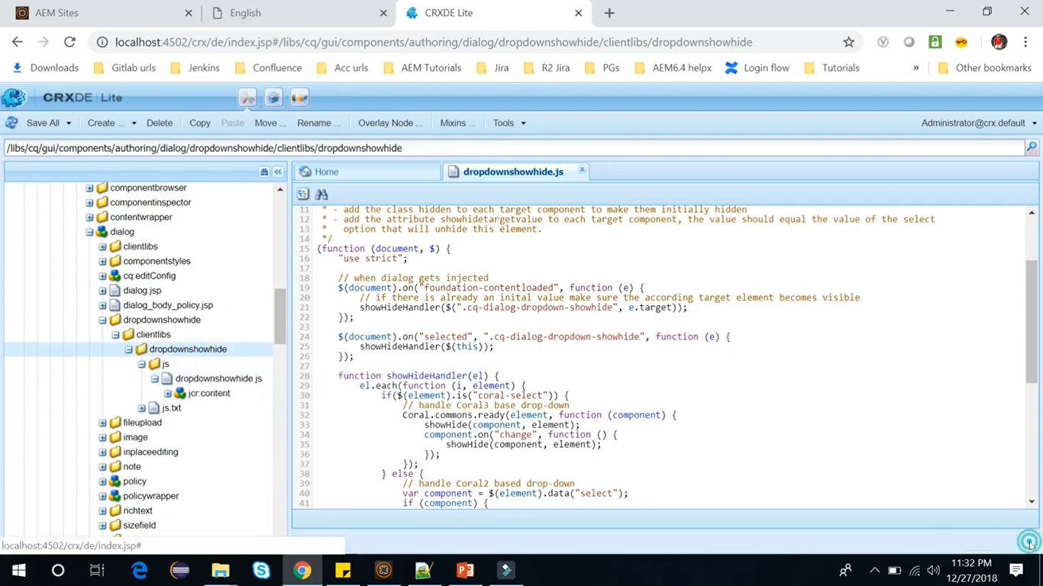

So, below are 4 steps **to use this client library** *with the dropdown select field*.

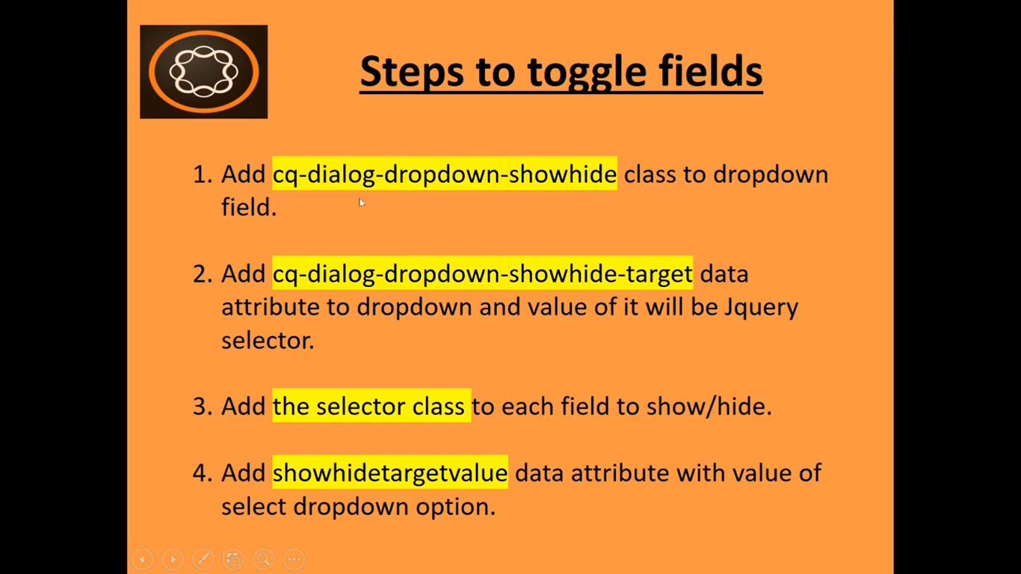

I have already performed these **4 steps** and created below shown dialog box on **Hello World** component.

Go to **English** page --> Double click on **Hello World** component to open its dialog box -->

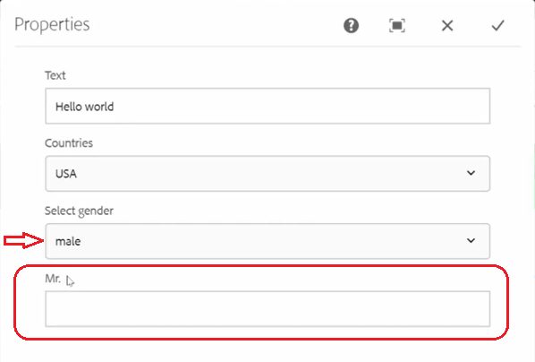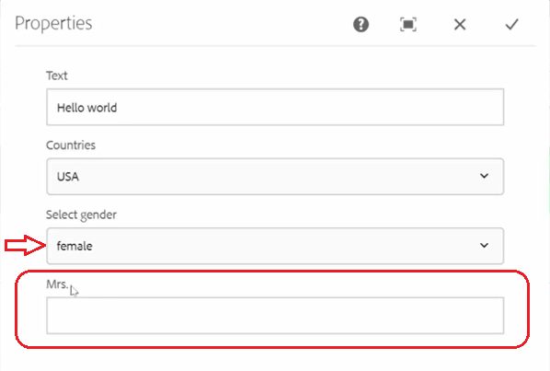

In Dropdown box and If we **select gender** as **male**, it shows “**Mr.**” Field label for the last text field.

If we **select gender** as **female,** then it will show “**Mrs.**” as Field label for the last text field.

We have already performed all the 4 steps in the hello world component. Let’s see these steps.

Go to the project go to **apps/demotraining/components/content/helloworld**.

**Delete** client library node **apps/demotraining/components/content/helloworld**/**clientlib-authoring.**

Because we are using the different client library named **dropdownshowhide** which we used above.

Go to the **helloworld/cq:dialog** -> **column** -> **items**-> **dropdown**.

1. So, the first step was to add **cq-dialog-dropdown-showhide** class to the dropdown field. So, we have this dropdown field and we have added a class **granite:class** and its value is **cq-dialog-dropdown-showhide**.
2. And then 2nd step was to add **cq-dialog-dropdown-showhide-target** data attribute and value of it will be jquery selector.

So, what we have done we have created our granite data attribute below this dropdown and here we have created our property of **cq-dialog-dropdown-showhide-target** and its value is jquery selector. So, we have used selector as **.showhidetargets**.

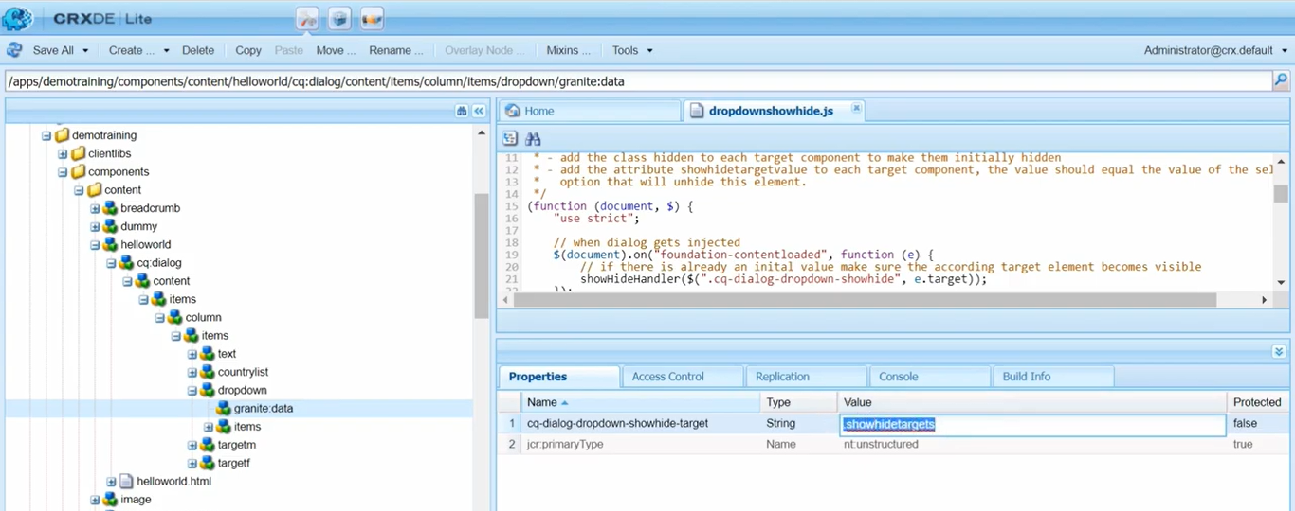

So, after doing this step, we need to add the selector class to each field to show/hide.

So, our selector is **showhide-target**. So, below dropdown we have this container (see below image) under which we can add several items (**targetm** and **targetf**).

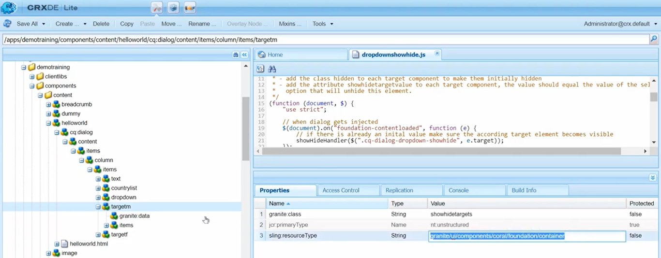

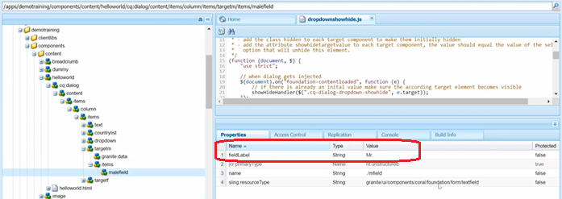

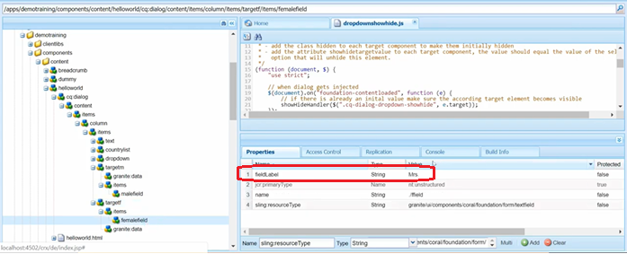

For eg : here we have added this text field which have this field as Mr and the 2nd is again a container and in which we have female field which has field level as Mrs. So, we can add several fields here to show/hide.

1. So, in the third step, we have added a **selector class** which will do show/hide functionality.

So, for both the containers **targetm** and **targetf** we have set below property-value pair.

|  |  |  |
| --- | --- | --- |
| **Field Name** | **Field Type** | **Field Value** |
| granite:class | String | showhidetargets |

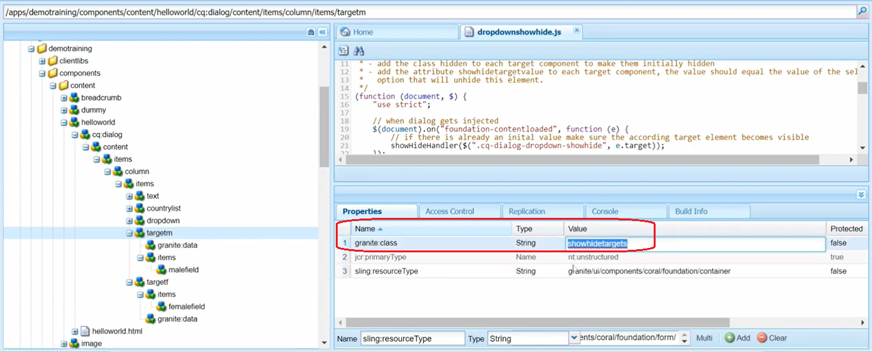

1. 4th step is to add **showhidetargetvalue** data attribute with the value of select dropdown option.

So, below **targetm** and **targetf** nodes we have created a **granite:data** attribute and its property is **showhidetargetvalue** and the value will be one of the options from this dropdown.

We have one of 2 option here. Male and female.

So, after doing all these 4 steps properly you will be able to put this show/hide using the select dropdown.

Once you are done with this you can go to **English** page and open the dialog box and you can change dropdown option with **male** and **female** and based on which text fields label gets changed “**Mr.”** and “**Mrs.”**

This is how you can show/hide fields with a dropdown.

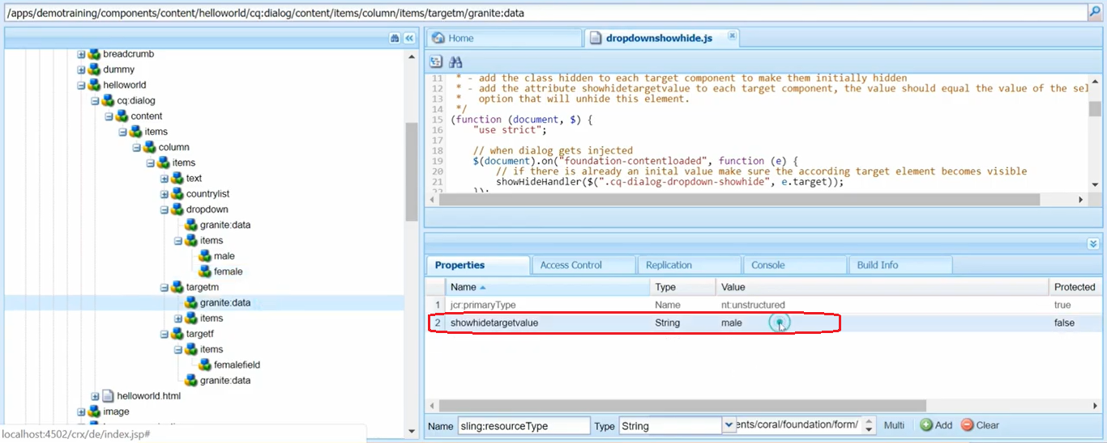

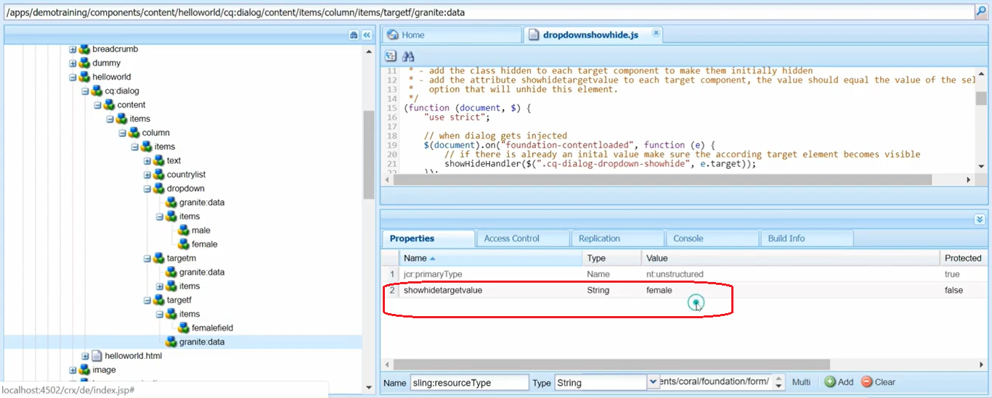

 

# 79. Show/Hide dialog fields with a Checkbox in AEM

In this section, we will how you can show/hide the dialog field with a checkbox.

In **English** page, we have a checkbox component with text as (Test checkbox show/hide here).

If we open this component it will open a dialog box and here, we have a checkbox.

If we **check** this checkbox, it will show 2 fields: College name and passing year.

If we **uncheck** this checkbox**,** it will hide these 2 fields.

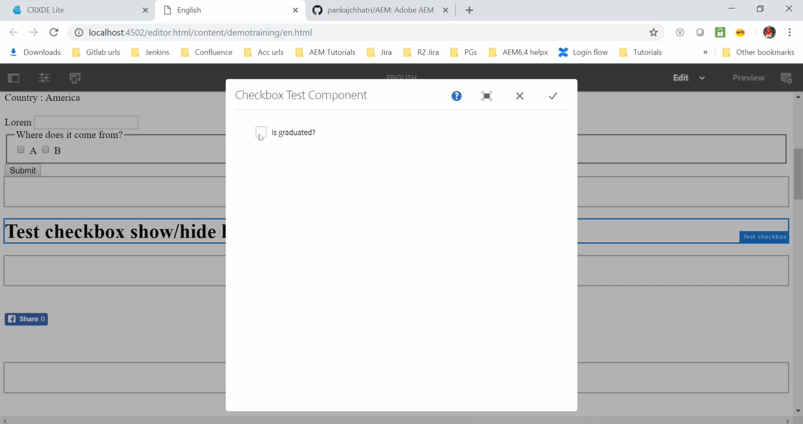

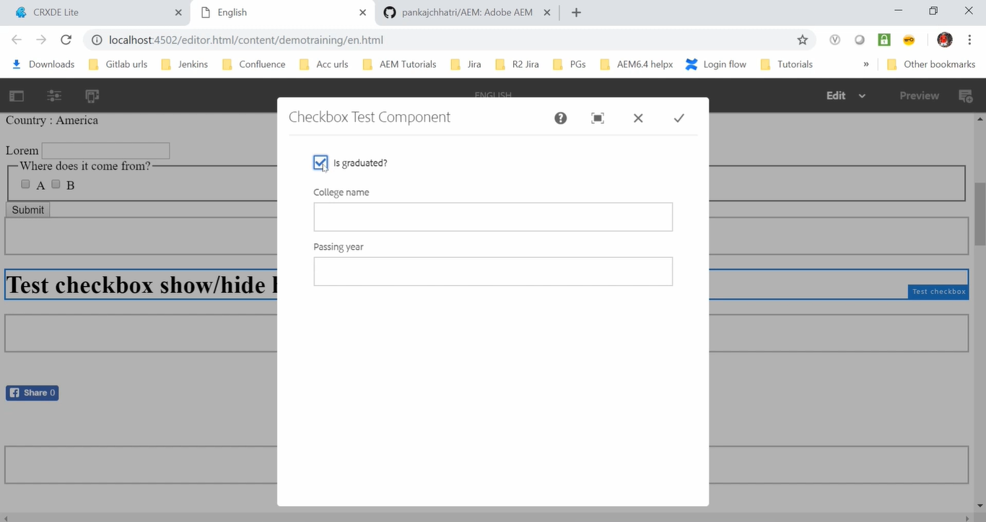

Out of the box. AEM does not provide this functionality.

But we have the JavaScript that we can use to achieve this functionality.

Go to <https://github.com/pankajchhatri/AEM> --> Go to [Developer course](https://github.com/pankajchhatri/AEM/tree/master/Developer%20course) --> [checkbox-showhide.js](https://github.com/pankajchhatri/AEM/blob/master/Developer%20course/checkbox-showhide.js)

This file contains JavaScript code which we will be using to achieve the toggle or show/hide functionality.

To use this custom functionality, we need a client library.

Go to **CRX/DE** path **/apps/demotraining/component/content/testcheckbox** component

You need to first create this **testcheckbox** component. Inside this component create textcheckbox.html file which contains text “Test checkbox show/hide here”.

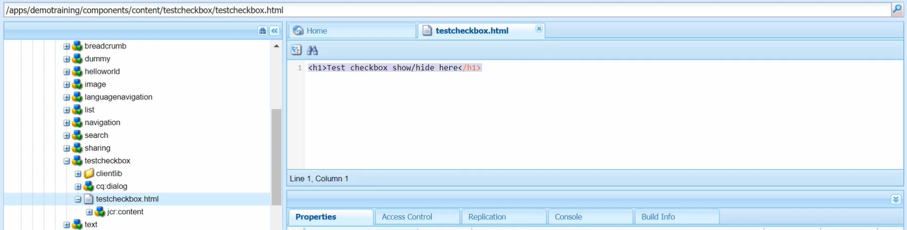

As we can see (image below), we have also created **dialog box** named **cq:dialog**.

We have also created, **client library** named clientlib with categories property as **cq.authoring.dialog.**

That means it is available in every dialog of AEM.

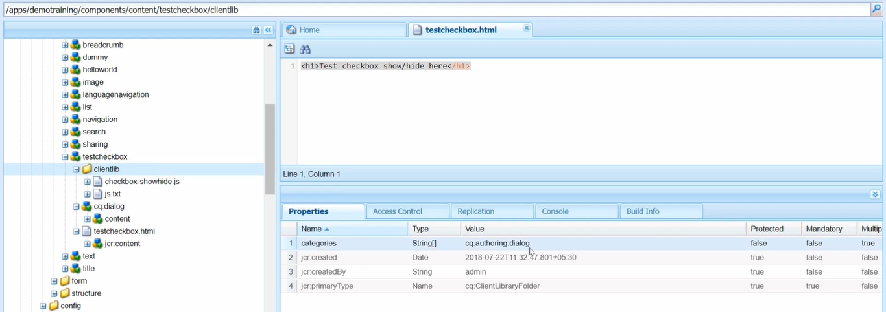

Now, in this client library I have created **js.txt** where I have entry of this JS. **Checkbox-showhide.js.**

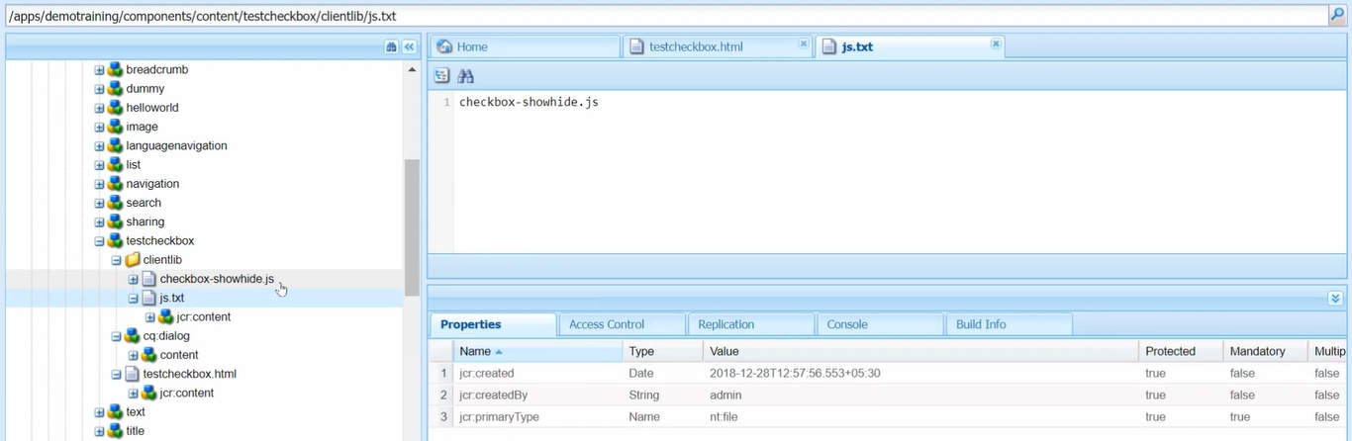

If you open this JavaScript this is what copied from my git and paste in this file.

So, to use this client library, we need to perform 3 steps which are mentioned in **checkbox-showhide.js**

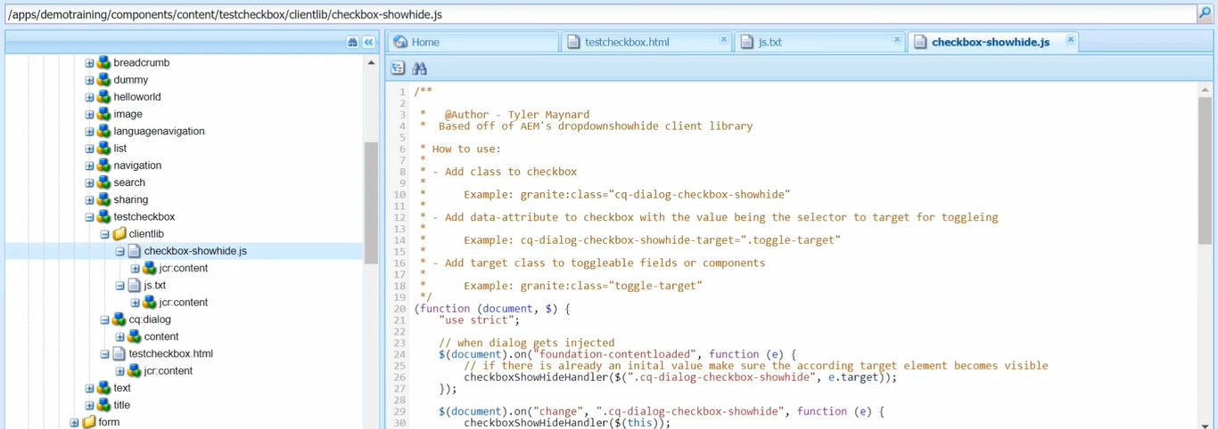

Go to the checkbox field node i.e. **testcheckbox** node. We have created a checkbox field in **cq:dialog** node.

Go to the **testcheckbox**/**cq:dialog/content/items/column/items/checkbox**.

This is the checkbox (see image below) with set of properties:

|  |  |  |
| --- | --- | --- |
| **Field Name** | **Field Type** | **Field Value** |
| granite:class | String | cq-dialog-checkbox-showhide |
| name | String | ./isGraduated |
| string:resourceType | String | granite/ui/components/coral/foundation/form/checkbox |
| text | String | Is graduated? |
| value | String | true |

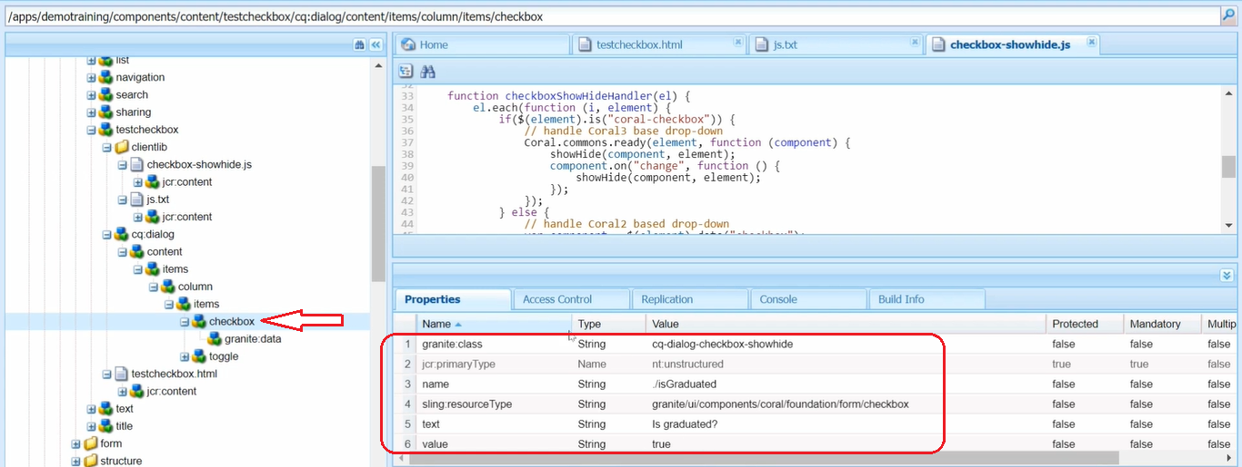

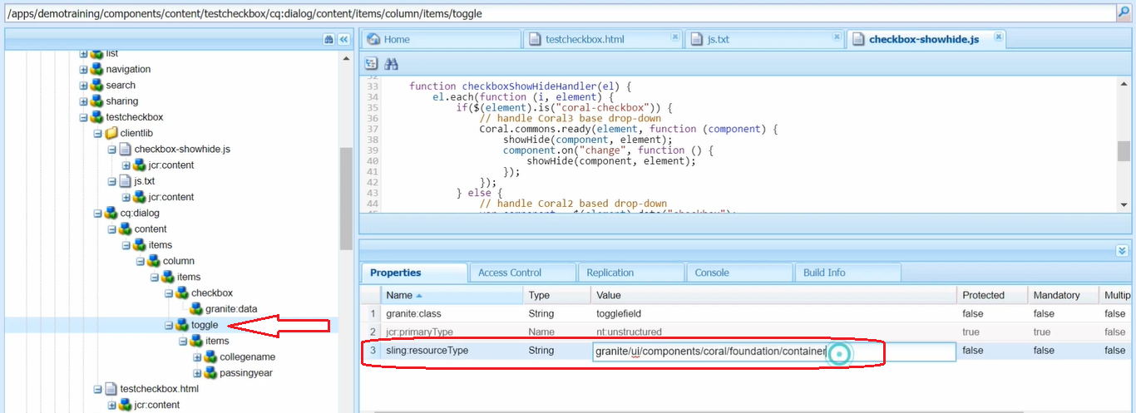

For the **fields** --> **College name** and **passing year**, we have created a container.

In **toggle** node (see image above) we have defined **sling:resourceType** as a **container**.

And below toggles there are items and below these we have 2 fields: College name and passing year.

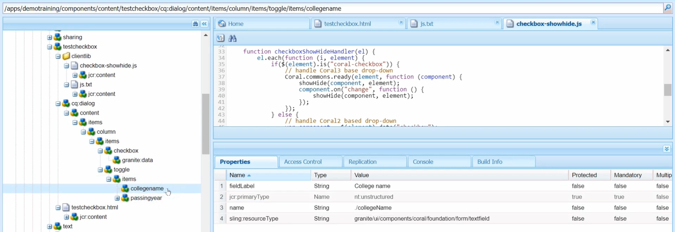

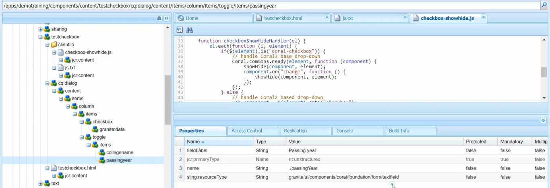

1. So, first your need to do add class to the checkbox.

We have already set property named **granite:class** with value **cq:dialog:checkbox-showhide** for the **checkbox** node.



1. Next step is to add **cq-dialog-checkbox-showhide-target** data attributeto the checkbox.

So, I have created a data attribute (property) of **granite:data** node with below property-value pair.

|  |  |  |
| --- | --- | --- |
| **Field Name** | **Field Type** | **Field Value** |
| cq-dialog-checkbox-showhide-target | String | .togglefield |

See Property **cq-dialog-checkbox-showhide-target** and its value would be a **selector for toggling**.

So, I have added a **togglefield** which isa class name. So, I have used **.togglefield**. We can use any classname here.

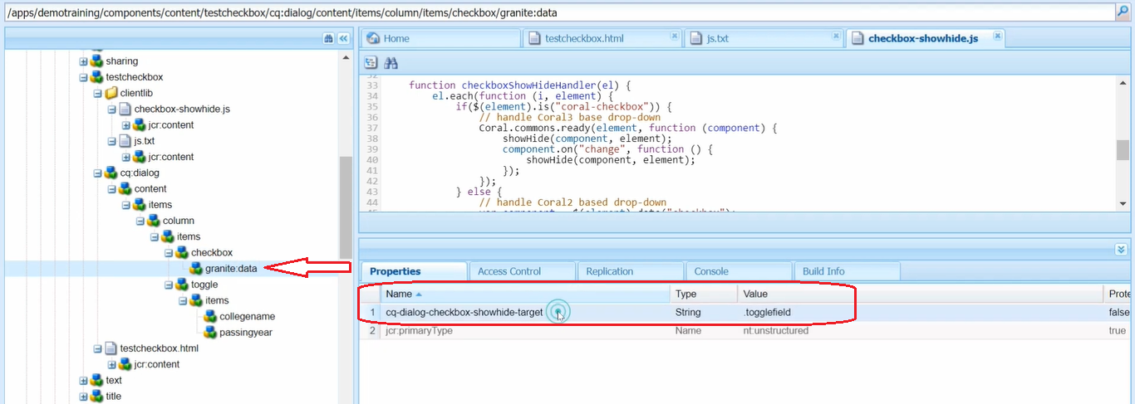

1. Now, let’s go to the container which I need to hide/show the fields. So we have 2 fields below toggle. Now we need to go to the toggle node that means I need to go to the container field and add the target class to the toggleable fields or component.

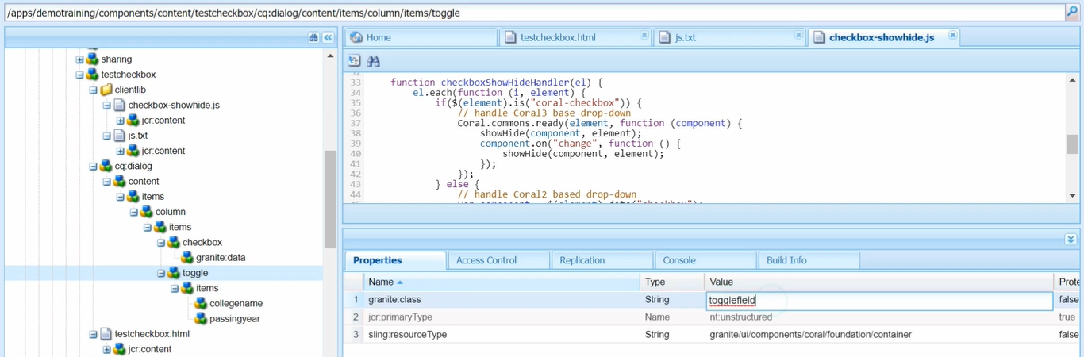

So, my fields are in toggle container (**toggle** node with **sling:resourceType** as **container**).

So, I will add class here **granite:class** and name is selector i.e. **togglefield** and don’t add dot(.) here

After these 3 steps you can see the English page can perform this functionality to show/hide checkbox.

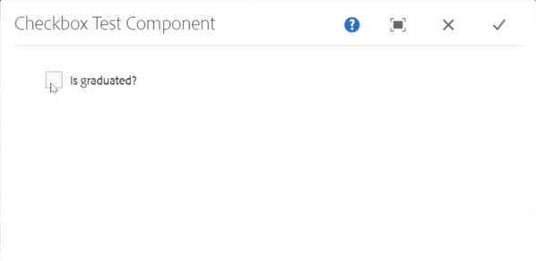 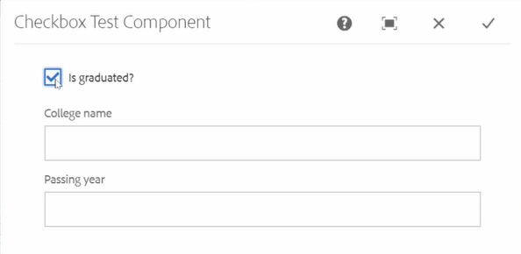

# 80. Sling Servlet using **Path** method

If you have ever worked with **Java web application**, you might have worked with **servlet** before.

**Servlets** handle the incoming **request** into a java-based application.

In this section, we will talk about sling servlet.

**Servlets** are registered as **OSGI service/bundle** in AEM.

**Sling** application use either **Scripts** or **Servlet** to **process HTTP request** in a **RESTful** way.

**Sling** is **resource oriented** which maps into a **JCR node**.

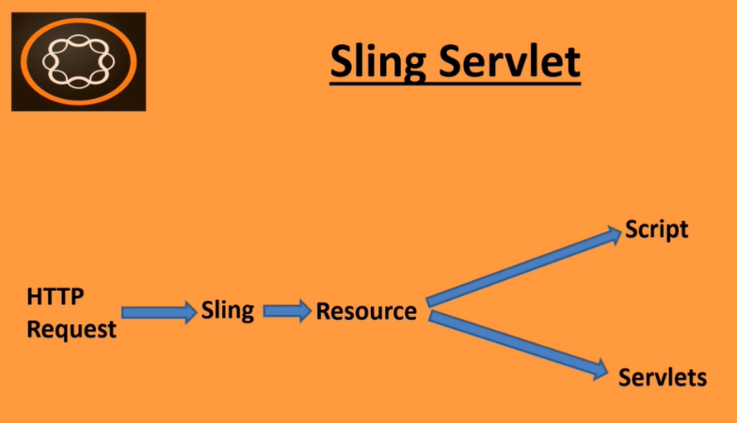

With **Sling** our **request URL** is first resolved to a **resource** and then based on the resource, it selects the actual **Servlet/Script** to handle request.

Requests are handled by either **Script/Servlet** in AEM.

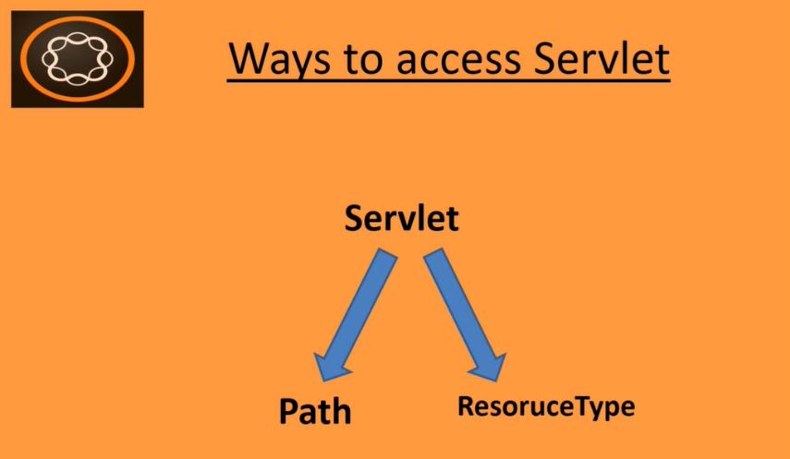

We can **access servlets in two ways**.

1. Path
2. Resource type.

The **Path** is **not** the **recommended** way and the **Resource type** is a **recommended** way of using in AEM.

We will discuss the reason behind it later. Let’s first **create** a **Servlet** using the **Path** method.

Open **Eclipse IDE**, I have this demo training project.

As we know **Servlet** can be registered as **OSGI services**.

So, we will have to create it with the **core** of our project.

This is my **demotraining.core** project (see above image)

Go to **Demotraining.core -> src/main/java -> com.aem.demo.core.servlet** (this is a package)

In this I will create a class and name is as **TestSlingServlet**.

Now I have already created this class in my GitHub. So, you can go to the GitHub.

Go to <https://github.com/pankajchhatri/AEM> --> [Developer course](https://github.com/pankajchhatri/AEM/tree/master/Developer%20course) --> [TestSlingServlet](https://github.com/pankajchhatri/AEM/blob/master/Developer%20course/TestSlingServlet) ->(copy and paste in eclipse class).

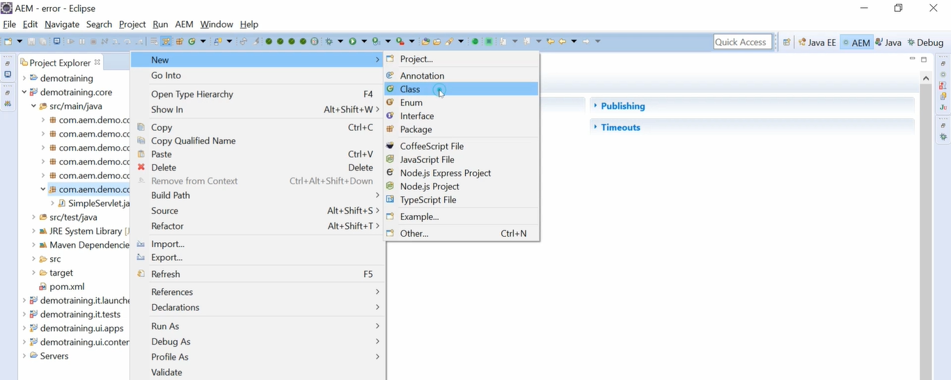

So, previously till AEM 6.2 **Felix SCR Annotation** were used.

With **Felix SCR Annotation,** we can define the **Servlet** using below syntax:

**@SlingServlet(paths= “/bin/trainingproject/testservlet”).**

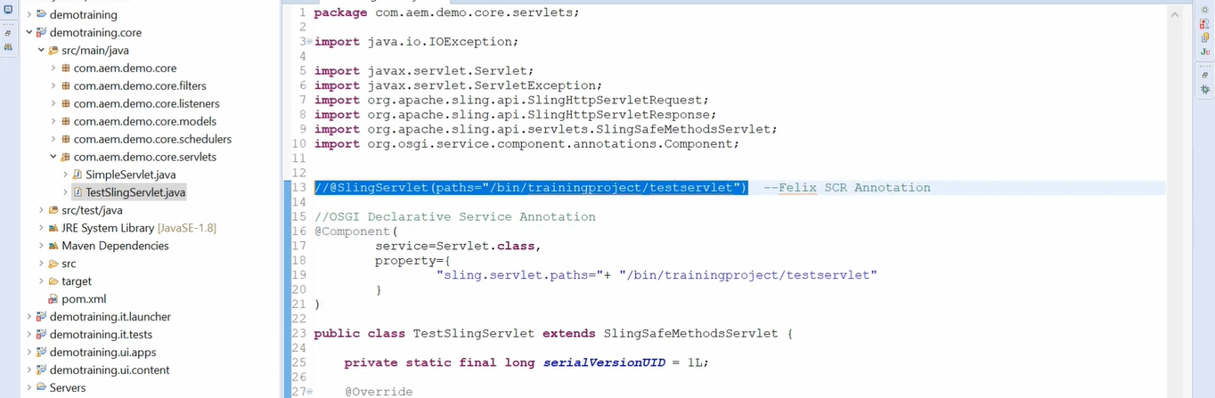

But AEM 6.2 onwards, **OSGI Declarative Service Annotations** are used.

With **OSGI Declarative Service Annotations**, we can define **Servlet** using below syntax:**@Component** and attribute as **Service = Servlet.class** and define the path in property as below

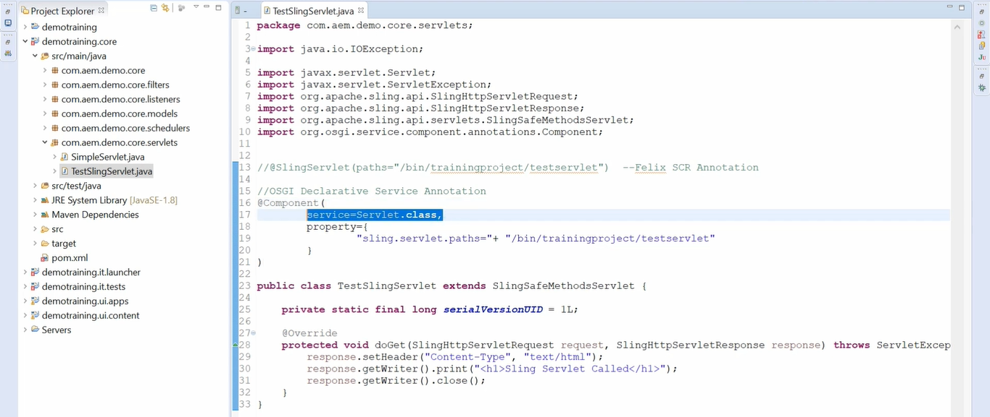

**TestSlingServlet** is our class name it is extending **SlingSafeMethodServlet** class.

If we are overriding **doGet** method, then we should use **SlingSafeMethodServlet** class.

If we are overriding **doPost** method, then we should use **SlingObjectServlet** class.

Here, I am using **doGet** so I am extending with **SlingSafeMethodServices** class.

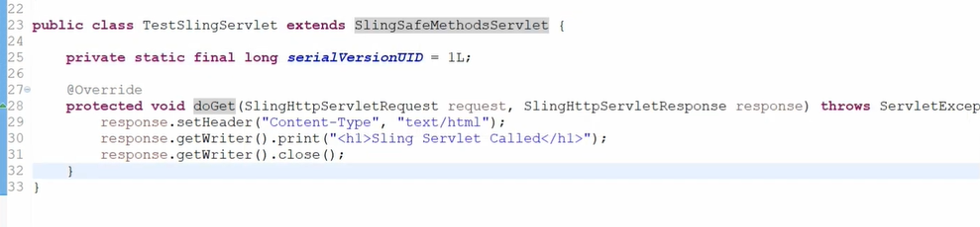

Inside we’re setting **header** with Content-Type as “text/html” and also writing text “Sling Servlet Called” which we will send the response.

Notice the path **/bin/trainingproject/testservlet** is where we can access this Servlet **TestSlingServlet**.

So, if we open URL, **http:localhost:4502/bin/trainingproject/testservlet**, then Servlet **TestSlingServlet** will be called.

Now let’s build this project.

Go to command prompt and execute command **“mvn clean install -PautoInstallPackage”.** Press Enter ↵

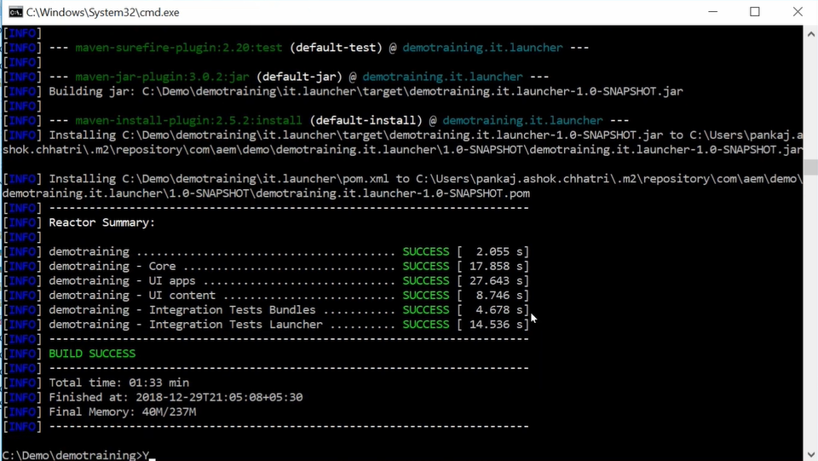

It will build our project. Once build is success you can go to the AEM path

**http://localhost: 4502/system/console/bundles** and refresh it and open our bundle by searching it on the page with our project name i.e. **demotraining** where we should find our servlet name i.e. **TestSlingServlet**

We can find it in below image.

Now to access this servlet, I need to put this path copy this path (**“/bin/trainingproject/testservelet”**) and let’s access this by entering URL **http://localhost: 4502/bin/trainingproject/testservelet**.

Now you can see that our **TestSlingServlet** has been called successfully and it is displaying text as **Sling Servlet Called**.

This is how you can define servlet using path and how you can access this.

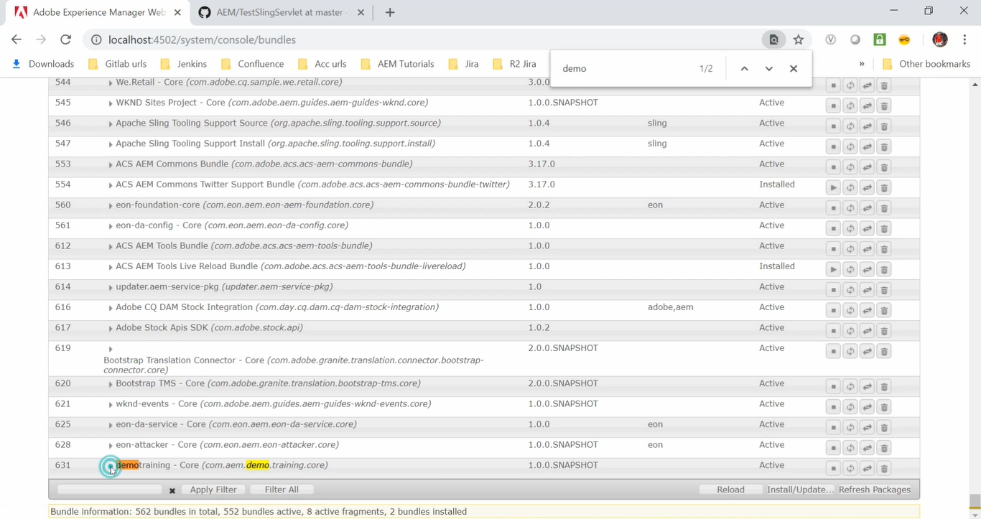

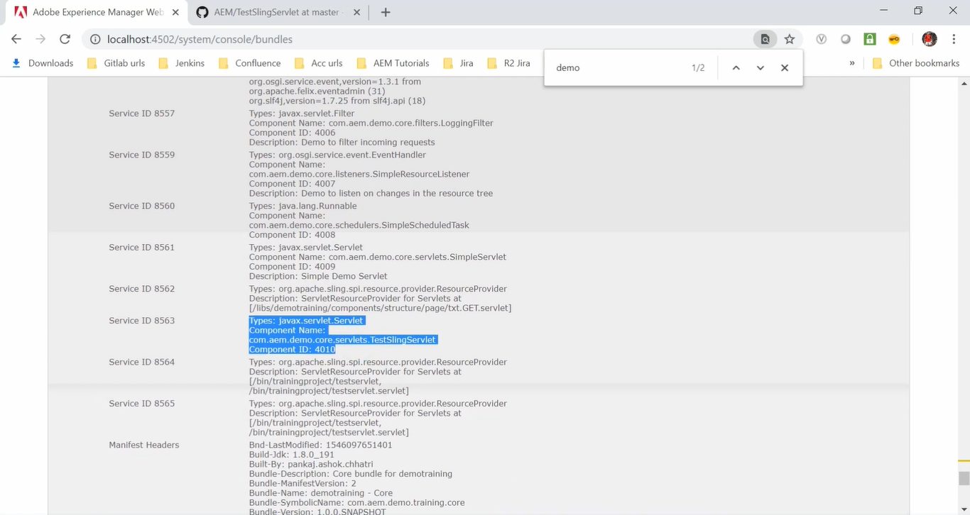

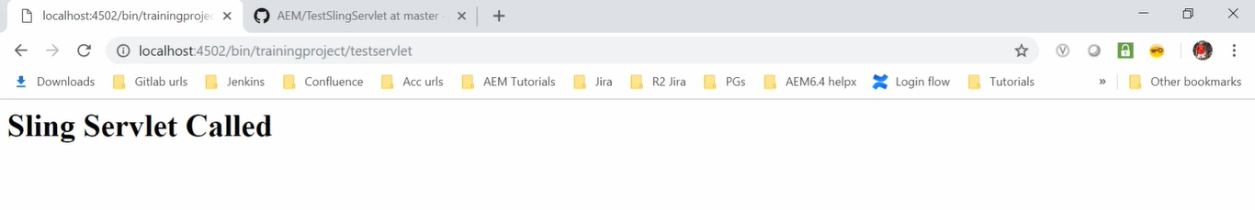

# 81. Sling Servlet using **ResourceType** method

In this section, we will discuss how to call Sling Servlet using the resource type.

So, In the last video we had created a servlet and called that Servlet using this path: [**https://localhost:4502/bin/trainingproject/testservlet**](https://localhost:4502/bin/trainingproject/testservlet)**.**

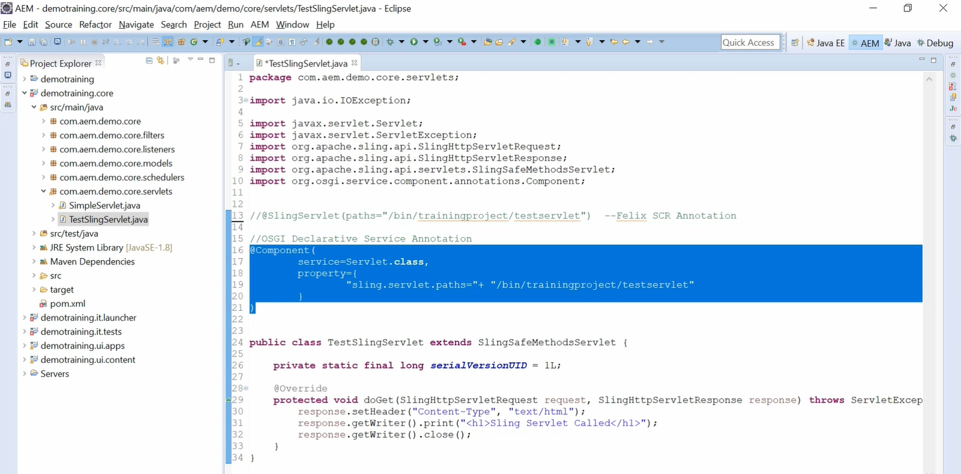

Inside **@component** we had defined the path (See highlighted text from above image).

When you **deploy** your **Servlet** on particular path, it **overrides** rest of the **parameters** or rest of the **attributes.**

Hence, it is **advisable** **to map** your **Servlet** with a particular **resource type** and a particular **selector**.

This will **hide** your **Servlet** and make **only** **available** to you on the **web page** that I have defined using that

**resource type** and **only** when a **particular selector string** is present in the **URL**.

Till **AEM 6.2**, we were using @SlingServlet(paths = “custom path”) using Felix SCR Annotation.

Now, let’s see, till **AEM 6.2**, how we could define Sling Servlet using resource type

Before code (using Path method):

**@SlingServlet (path = “/bin/trainingproject/testservlet”, selectors = “sample”).**

After code (using resourceType method):

**@SlingServlet (resourceType = “demotraining/components/structure/page”, selectors = “sample”).**

So, till **AEM 6.2**, above mentioned was the method of defining **Sling Servlet** using **resourceType**.

Now, let’s see how to define **Sling Servlet** using **resourceType** using **Declarative Service Annotations** (**AEM 6.2 onwards**).

So, for that we need **@component** and attribute as **Service = servlet.class** and in the Property we can define the path **“sling.servlet.resourceTypes=”+ “demotraining/components/structure/page”.**

To get this resource type, copy the value of property **sling:resourceType** of **/content/demotraining/en/jcr.content** CRX/DE nodeand map Servlet with resourceType value (see highlighted text below) and set selector to sample i.e. **“sling.servlet.selectors=” + “sample”.**

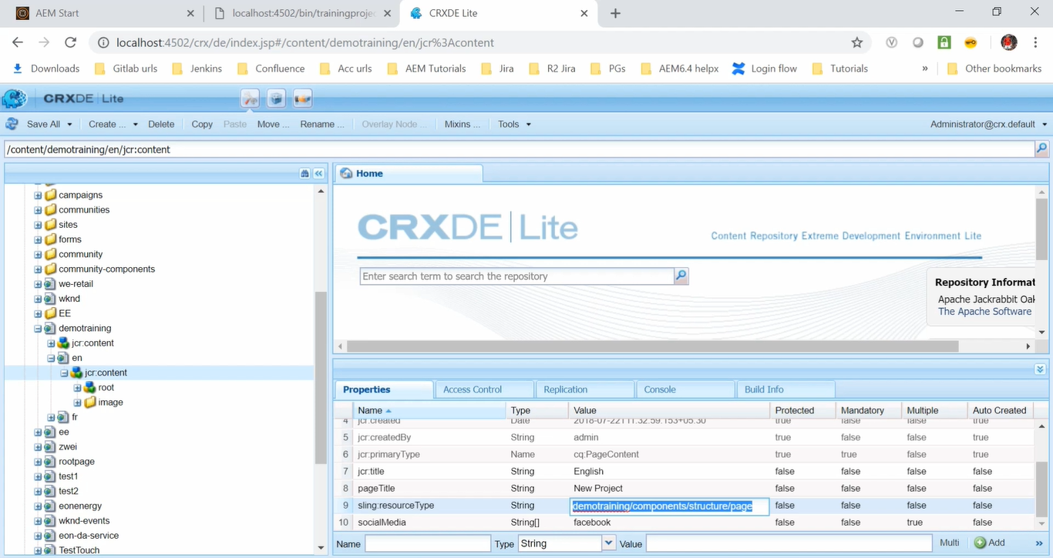

**Before code** (using Path method):

@component (

service = Servlet.class,

property = {

“sling.servlet.paths=”+ “/bin/trainingproject/testservlet”

}

)

**After code** (using resourceType method):

@component (

service = Servlet.class,

property = {

“sling.servlet.resourceTypes=”+ “demotraining/components/structure/page”,

“sling.servlet.selectors=” + “sample”

}

)

Once it is done go to the command prompt and build.

Execute this command **“mvn clean install -PautoInstallPackage”.**

Now, go to previous URL <http://localhost:4502/bin/trainingproject/testservelet>

We will get 404 error, because we have removed the path.

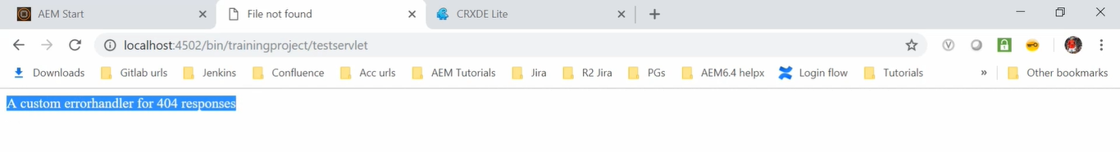

We have used resourceType as **demotraining/components/structure/page.**

Go to **Site Console** [http://localhost4502/sites.html/content](http://localhost4502/sites.html/content/demotraining) --> **DemoSite** --> **English** page --> **Edit** icon

It will open our page and remove editor.html from the path

<http://localhost4502/editor.html/content/demotraining/en.html>

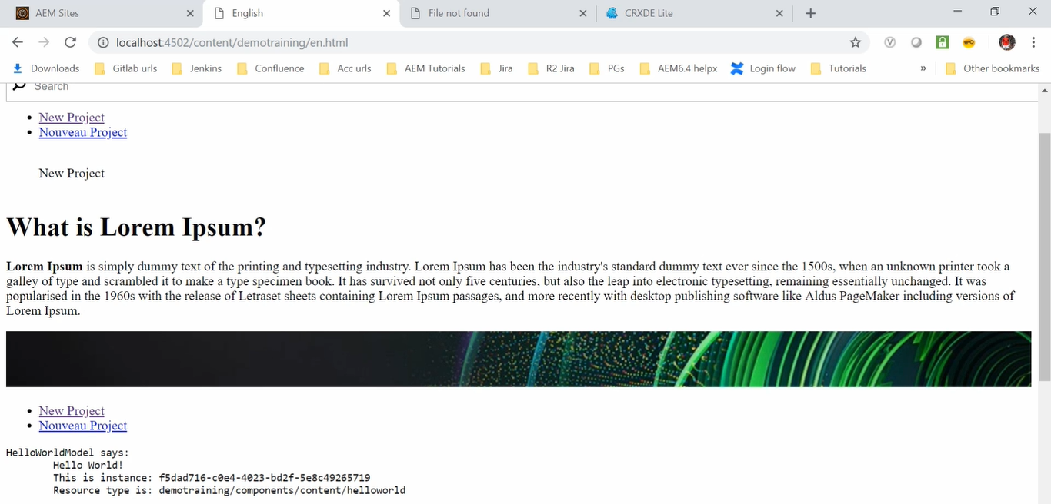

Our page has been called, but our **Servlet** is not yet got called, even though our page using resourceType.

To call the **Servlet** we need to use **Selector**. Our **Selector** name is sample, so add sample in URL like this <http://localhost4502/content/demotraining/en.sample.html>

So, as we can see the servlet has been called.

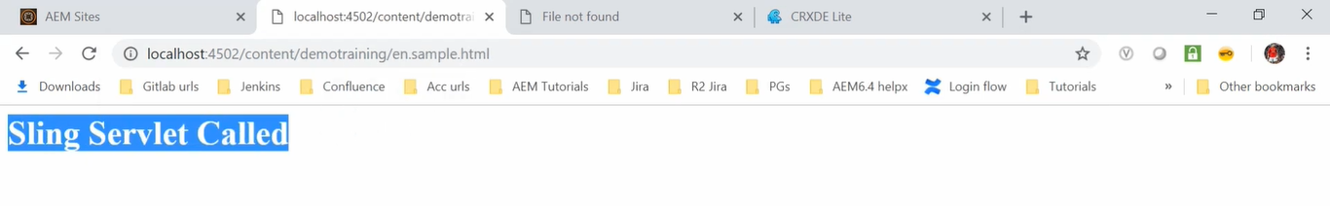

So, in order **to** **hide your servlet,** you can **associate your servlet** with a **resourceType** and **selector**.

This will **prevent unauthorized access**.

So, if a developer who know the **resourceType** and **selector** combination will be able to call **Servlet** easily.

Now you know how you can call your **Servlet** using **path** and using **resourceType**.

Calling **Servlet** using **resourceType** is the recommended way is to call servlet.